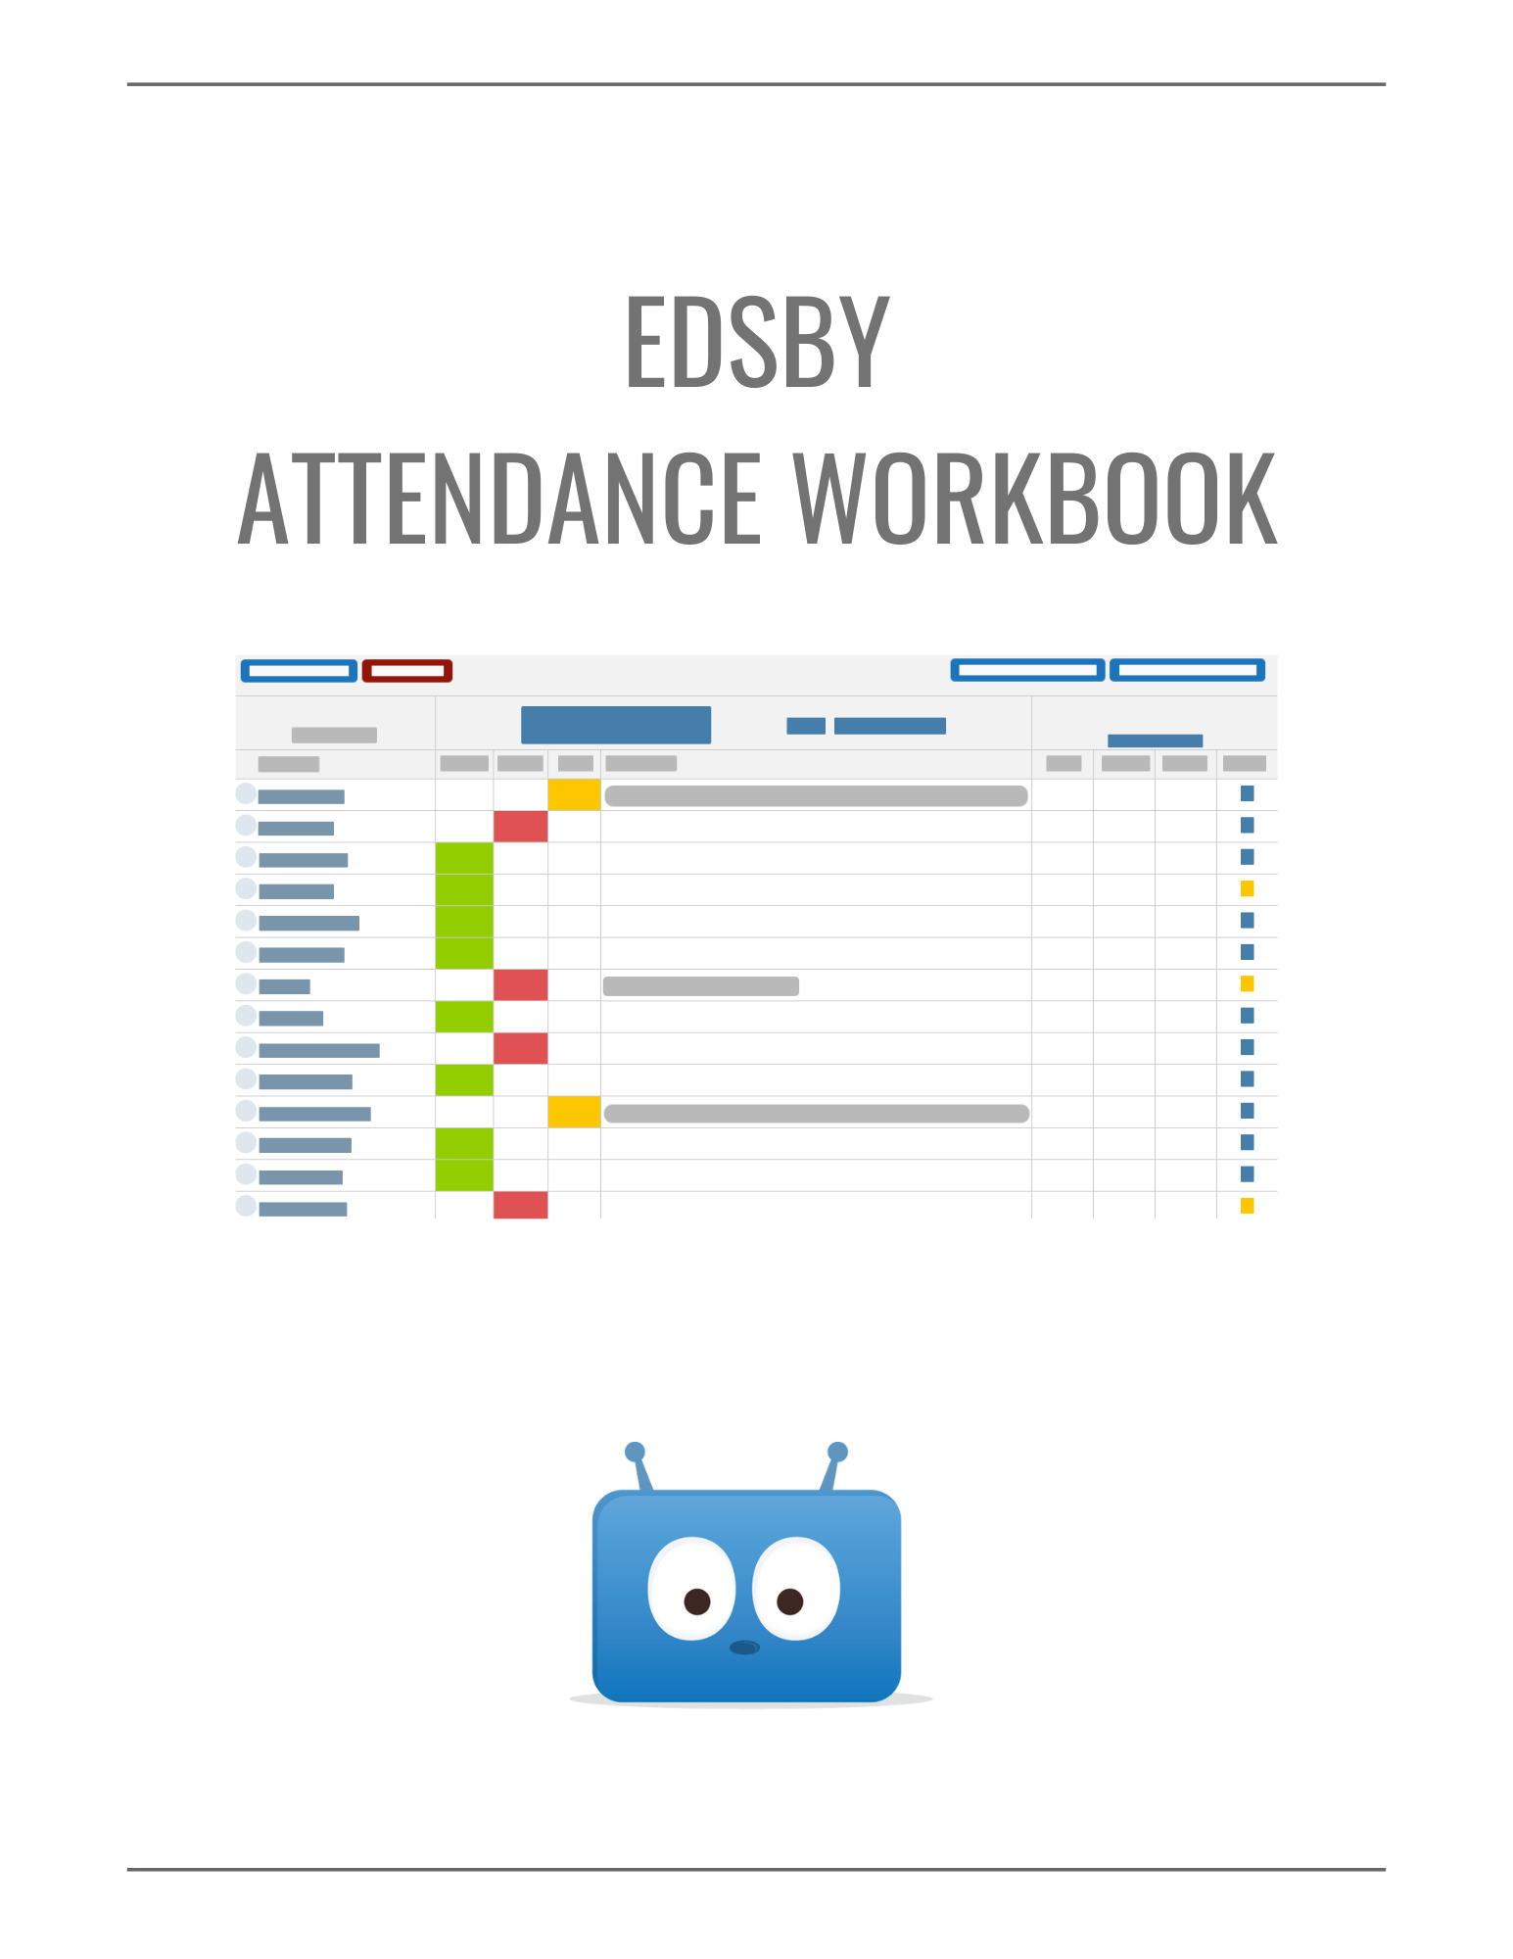
In this session, we’ll be covering the core Edsby skills for the Attendance Office. Click the hyperlinks to jump to the part of the document where each skill is discussed.

Navigate Attendance Zoom
I can navigate to the Attendance Zoom.
I can use filters and search to narrow down Attendance Zoom info.
I can navigate the four different tabs of the Attendance Zoom.
I can use Away Today, Planned Absence, Admit Slip, and Sign Out in the Student Tab.

Common Tasks
I can resolve both individual and multiple Attendance Incidents.
I can notify parents of Attendance Incidents.
I can issue Admit Slips for both individual and multiple students.
I can perform bulk actions on Attendance Sheets.
I can submit Attendance Sheets on behalf of a teacher.
I can export Attendance data.

Finding Attendance Info
I can view Attendance info in the Students Zoom and Student Report.
I can view a student’s Attendance Summary Report in the Panorama or Students Zoom.

Supporting Substitutes
I can navigate the Classes Zoom.
I can print Attendance Sheets.
I can assign ‘Substitute’ roles in an Edsby Class.

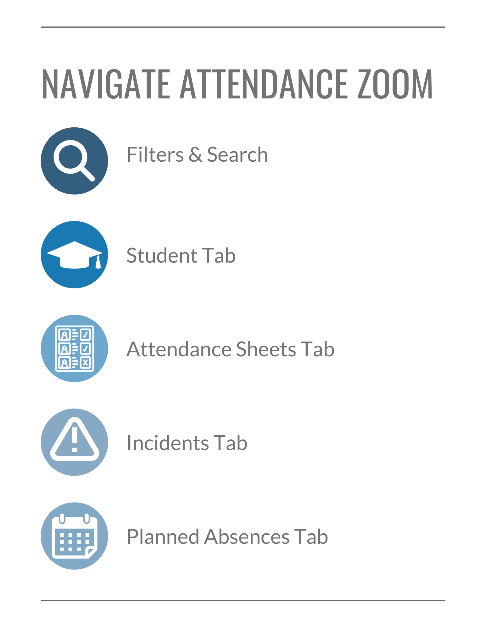

Navigating the Attendance Zoom
In general, the Attendance Workflow involves:

- The Attendance Office creating Planned Absences based on parent emails or phone calls
- The Attendance Office approving parent-submitted Planned Absences
- Teachers submitting Class Attendance Sheets to the Attendance Office
- The Attendance Office managing late and early-departing students

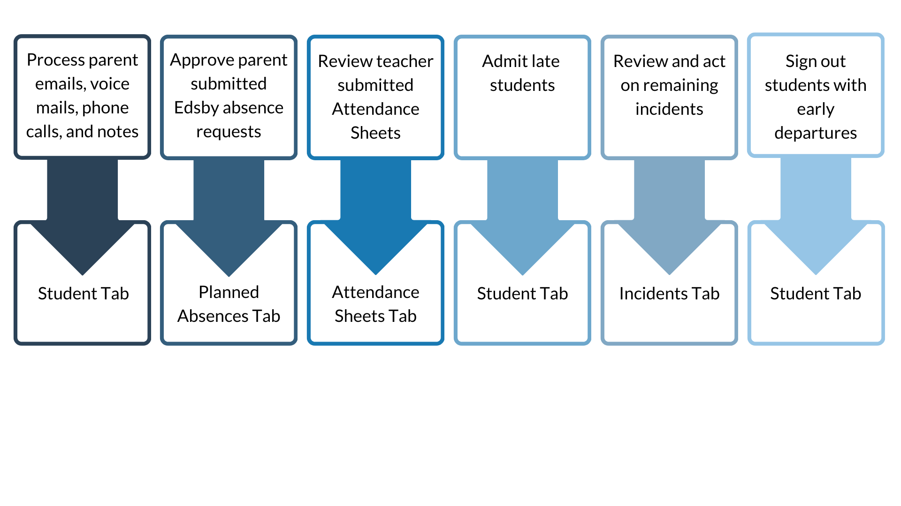

This is all done within the Attendance Zoom located on the right side of your Home Screen and including a counter of unapproved parent-submitted Planned Absences.

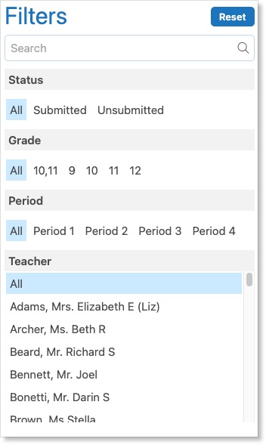
Filters & Search
The Attendance Zoom includes four tabs: Student, Attendance Sheets, Incidents, and Planned Absences.

Within each tab, the information can be filtered and narrowed down using the search bar and filters. Clicking on a filter will update the list to include items that meet the filter criteria.

Let’s take a closer look at each tab in the Attendance Zoom.

Student tab
The Student Tab is the default screen of the Attendance Zoom. This tab enables you to view a student’s attendance history as well as quickly perform common attendance actions for specific students including issuing an Admit Slip, Signing Out the student, marking the student as Away Today, or creating a Planned Absence.

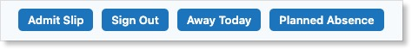

Search for a student’s name in the search bar to view their Attendance Summary Report. The report has two views: List View and Year Calendar View.

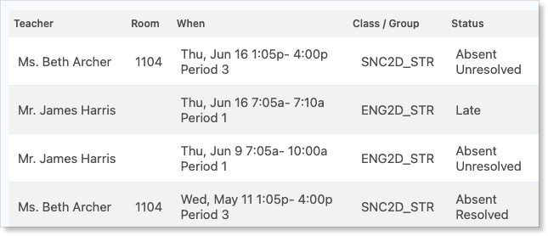

List View displays all attendance incidents associated with the given student and provides common attendance actions for the student.

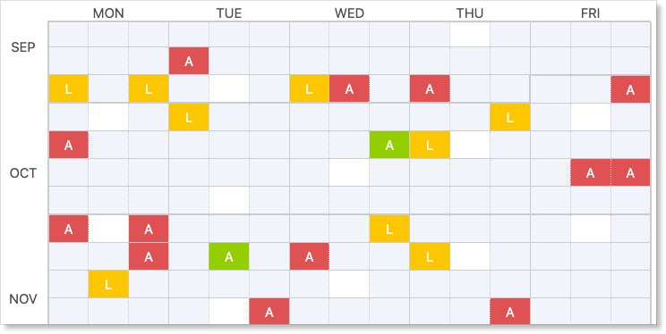

Year Calendar View displays the student’s Attendance Summary Report for the past year. This view enables you to identify any attendance issues.

Activity – Processing Parent Emails, Calls, and Notes
You may often start the day by processing emails, phone calls, voice mails, and notes from parents. The Student Tab is used to work quickly through parent communication regarding absences.

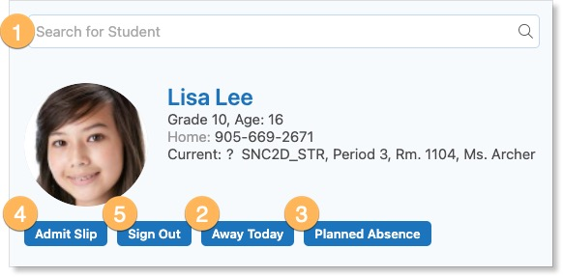
- Search for the student’s name.

- Click Away Today if the parent is reporting that their child will be away the current school day. Fill out the Planned Absence form.

- Click Planned Absence if the parent is reporting an absence for dates in the future. Fill out the Planned Absence form.

- If a student arrives late, click Admit Slip, and fill out the form. Admit Slips can either be issued within Edsby or also printed.

- When a student is leaving school before the end of the day, click Sign Out. Fill out the Planned Absence form.

  - Attendance Sheets Tab
The Attendance Sheets tab lists all submitted and unsubmitted attendance for the day.

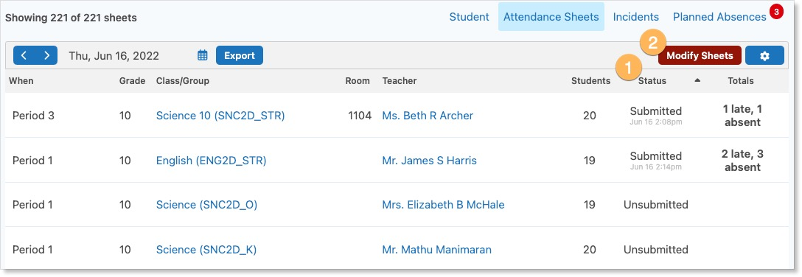

- The Status filter enables you to focus on either unsubmitted or submitted attendance sheets.

- Bulk attendance actions like cancelling Classes or accounting for school activities can be performed on this page and will be discussed later.

  - Incidents Tab
The Incidents Tab lists all students that have been marked as absent or late by a teacher in the school. As teachers submit their Class Attendance Sheets to the Attendance Office, the student absences will be added to this list.

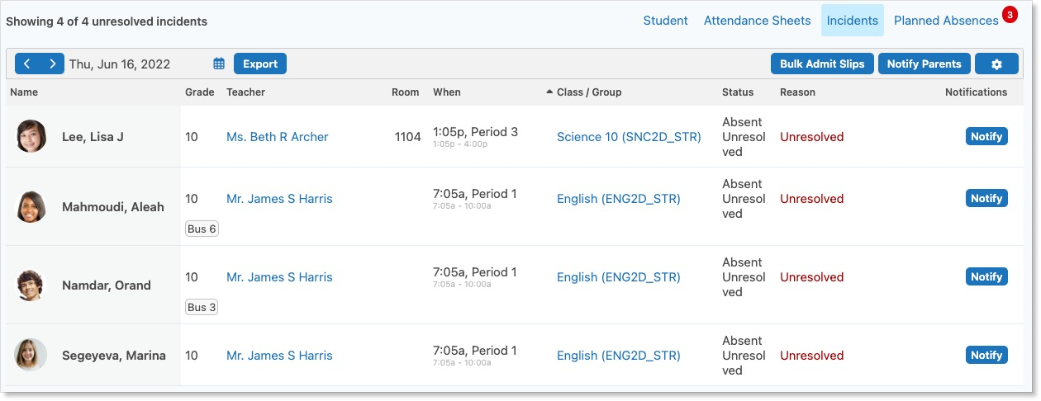

  - Planned Absences Tab
The Planned Absences Tab lists all the day’s Planned Absences created by both the Attendance Office and through parent submission. This tab also includes the ability to create new Planned Absences which will be discussed shortly.

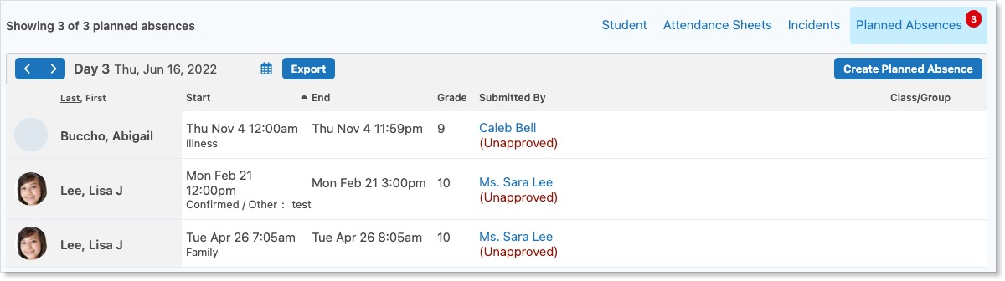

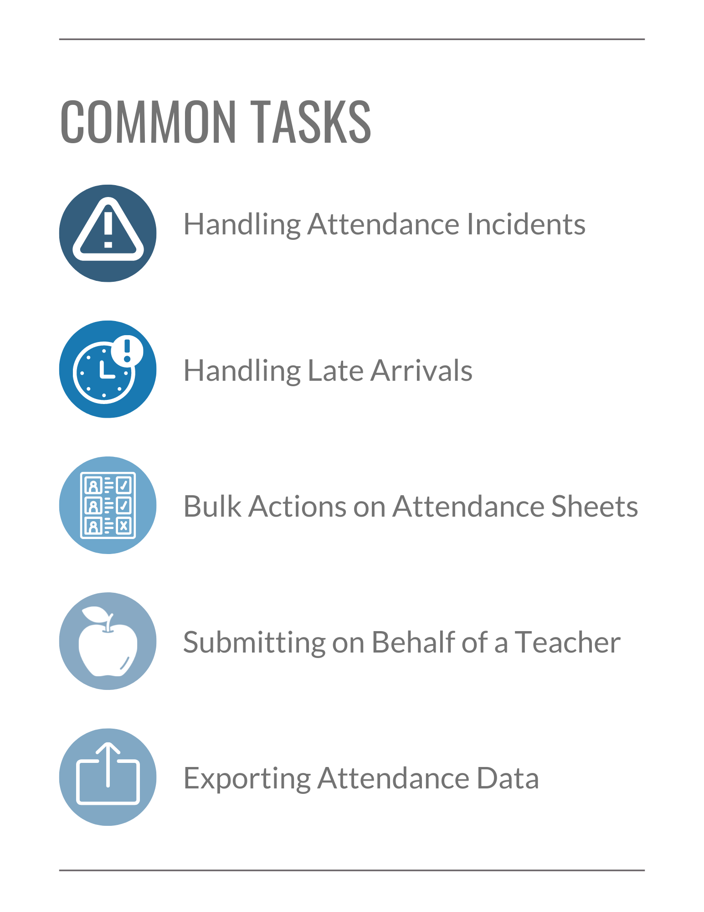

Common Attendance Tasks
In this section, you will practice performing common Attendance Office tasks.

Activity – Handling Attendance Incidents
An Attendance Incident is automatically created when a student is marked absent or late. You can resolve both individual and multiple incidents. Navigate to the Incidents tab.

 | Resolving Individual Incidents  To resolve an individual incident:  - Click on the incident row to open the Attendance Incident form.  - Complete the form by choosing a Reason and Away time.  - Comments are optional, but when entered, can be seen by teachers, parents, and the student.
 | Resolving Multiple Incidents  Students with common reasons and length of absences can be resolved together. For example, all students who are ill for the entire school day.  - To apply the same reason and absence length to multiple incidents, click the gear icon.  - Using the checkboxes next to the student names, select which students to include in the Planned Absence.  - Click Create Planned Absence.  - Create a new Planned Absence and fill in the time range and reason.

Learn more about resolving Attendance Incidents here.

Activity – Notifying Parents of Incidents
You may wish to notify the parents/guardians of students with Attendance Incidents. Parents must have an Edsby account and have attendance notifications enabled for their child to receive these notifications.

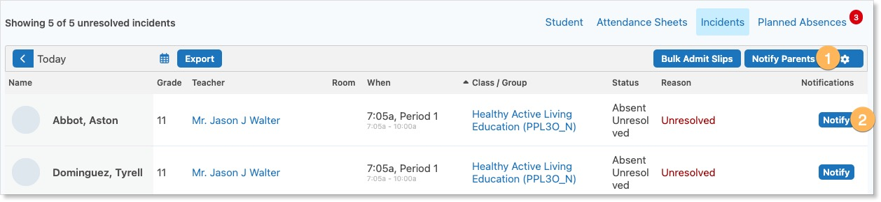

- In the Incidents tab, Click Notify Parents to send an Edsby notification to every parent/guardian linked to each student’s account.

- Parents for specific students can be notified by clicking Notify in the student’s row.

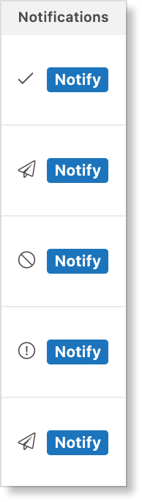
After you have notified parents, the Notifications column updates to reflect the status of each notification.

- An airplane indicates the notification was sent successfully but the parent has not yet responded.

- The no sign icon indicates the notification attempt failed and the parent could not be notified. This is likely the result if the parent does not have an activated Edsby account or does not have notifications enabled on their account.

- A checkmark indicates the parent has confirmed the absence and the incident is now resolved.

- A circle with an exclamation point indicates the parent has not confirmed the absence and have responded to the notification saying they did not know about the child’s absence.

Activity – Handling Late Arrivals
There are three options an organization can choose from to handle late arrivals:

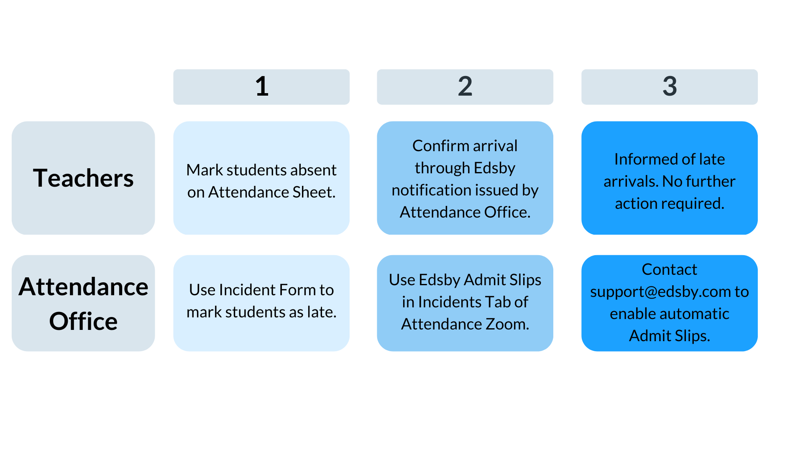

Let’s walk through the second option.

 | Issuing an Admit Slip for a Single Student  If there is only one student arriving late at a time, search for the student’s name in the Student Tab.  - Click Admit Slip.  - Fill in their arrival time and reason.  - Click Issue or Issue and Print if you would like to keep a hard copy of the slip.
 | Issuing Admit Slips for Multiple Students  To issue admit slips for multiple students, navigate to the Incidents Tab.  - Click Bulk Admit Slips.  - Enter the names of the students.  - Enter their arrival time and reason.
 | Issuing Admit Slips for Unresolved Attendance Incidents  Admit slips can also be created for multiple students who have unresolved Attendance Incidents.  - In the Incidents Tab, click the gear icon.  - Select the students.  - Click Bulk Admit Slips and fill out the form.

When the teacher confirms the students have arrived in Class, the reason code will change to Late.

Additional details can be found here.

Activity – Bulk Actions on Attendance Sheets
The Attendance Sheets Tab enables you to modify the Attendance Sheets of multiple Classes or an individual Class through the Modify Sheets feature. Let’s walk through a few examples.

 | Full-Day School Closure  If there is a school closure for the entire day such as for a snow day, the Attendance Sheets need to still be submitted for the scheduled Classes.  - Use the filters to include future classes for the day.  - Click Modify Sheets.  - Select Submit Sheets.  - Select Replace code on sheet to override any Planned Absences for the day.  - Choose how you want to mark all students.  - Give a reason, School Closure in this case.
 | Mid-Day School Closure  There may be instances where your school has a mid-day closure.  - Use the filters to include future classes for the day.  - Use the Period filter to select the remaining periods of the day.  - Click Modify Sheets.  - Select Replace code on sheet.  - Choose how you want to mark all students.  - Give a reason, School Closure in this case.
 | Cancelling an Individual Class  Bulk actions can be done to cancel Classes as well.  - To cancel an individual Class, hover over the Status state and click Modify Sheet.  - Select Cancel Class.
 | Cancelling Multiple Classes  Multiple Classes can be cancelled at once.  - Click the gear to reveal the checkboxes.  - Select the Classes to include.  - Click Modify Sheets.  - Select Cancel Class.

Additional examples can be found here.

Activity – Submitting Sheets on Behalf of a Teacher
There may be instances when the Attendance Office needs to submit an Attendance Sheet on behalf of a teacher. This is done in the Attendance Sheets Tab.

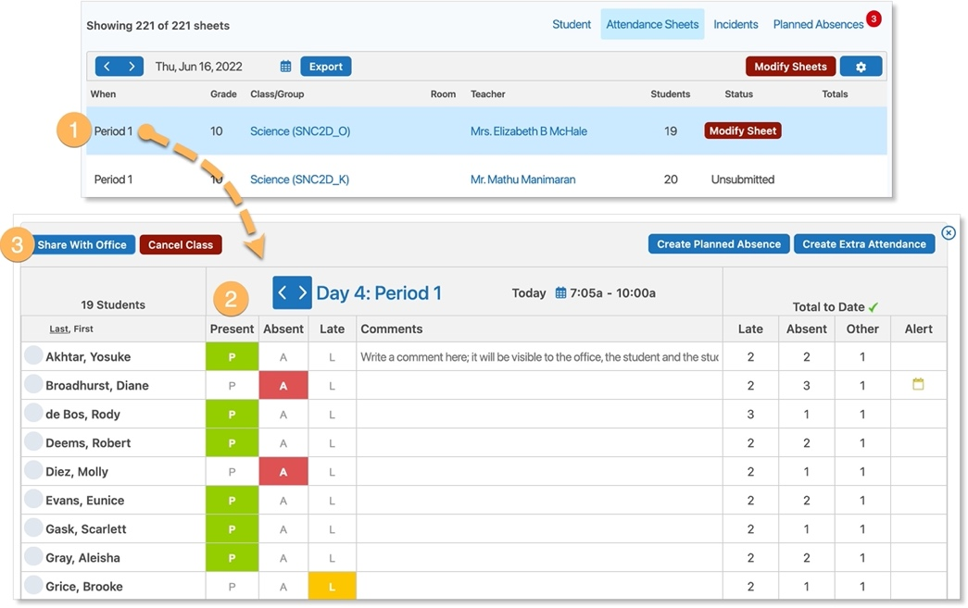

- Navigate to the specific Attendance Sheet and click the Period to open it.

- Fill out the form.

- When you are finished, click Share with Office.

Activity – Exporting Attendance Data
After processing the parent emails, voice mails, calls, and notes, approving parent-submitted requested absences, and admitting late students, you may want to export the list of absent students to an external system.

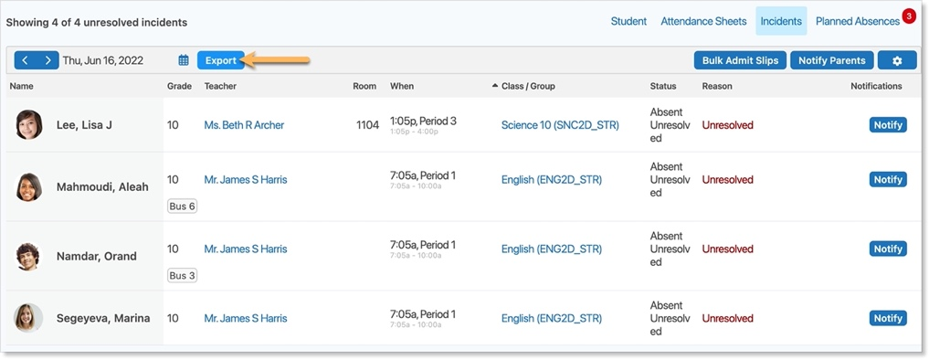
In the Incidents Tab, narrow down to the Incidents you wish to include in the export. Click Export. Fill out the form and save the Export.

Details on the export form can be found here.

  - 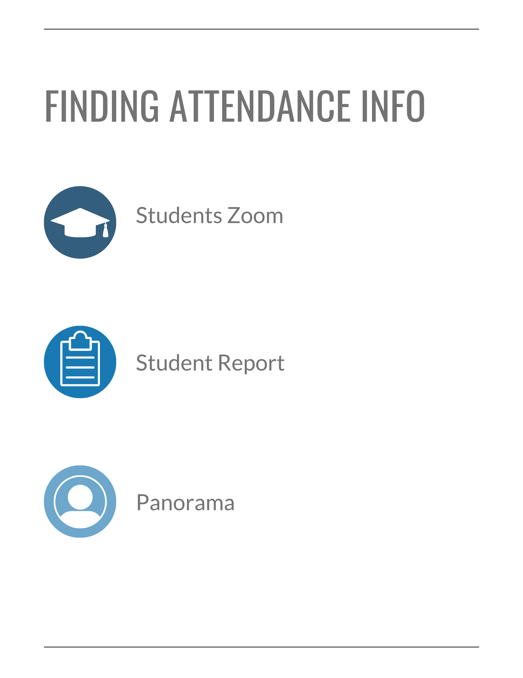

Finding Attendance Info in Edsby
While the Attendance Zoom is focused on resolving Attendance Incidents and is the main area you will likely use, attendance information is also included in the Students Zoom, the Student Report, Attendance Sheets, and the Panorama.

  - Students Zoom
The Students Zoom includes a student’s Attendance Totals and a link to their Attendance Summary.

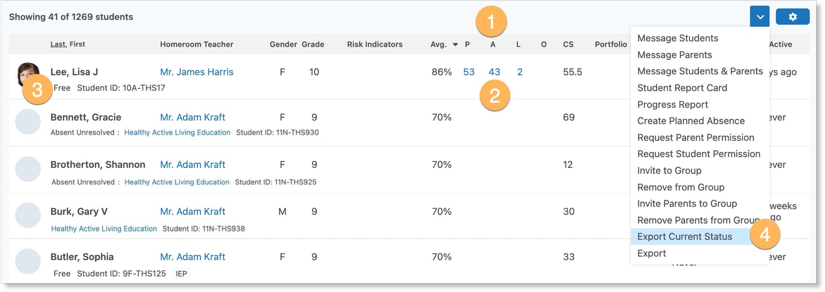

- To sort the Zoom by Attendance, click one of the P, L, A, or O columns. O means Other and represents sanctioned absences such as school activities.

- To view a student’s Attendance Summary Report, click on the student’s attendance totals. Note: this is the same report as seen in the Year Calendar View of the Attendance Zoom’s Student Tab.

- The Students Zoom displays the Attendance Status and Class of each student for their current period. This is based on what has been submitted in each Attendance Sheet and gets reset at the beginning of each new period.

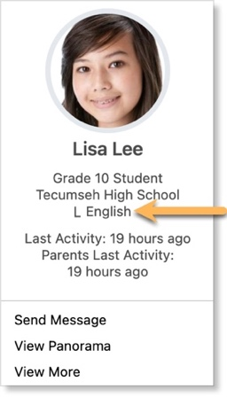
- Use the drop-down menu to export a csv file of the current attendance status for all students in the current period.

Attendance Status is also displayed in a student’s Mini-Profile found by hovering over their name within Edsby.

  - Student Report
The Student Report lists a row for each of a student’s Classes and additionally includes separate totals for Present, Absent, Late, and Other.

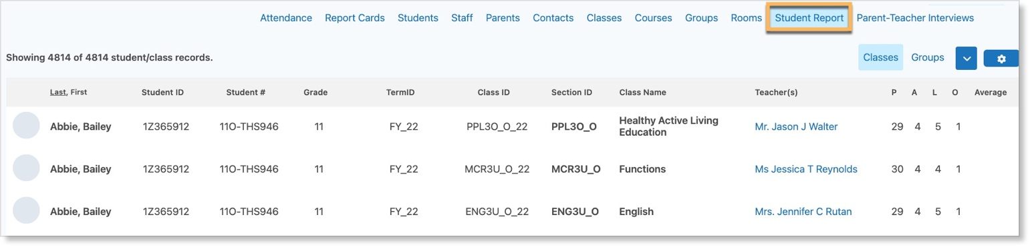

Navigate to the Student Report by selecting the Student Report link at the top of the Students Zoom.

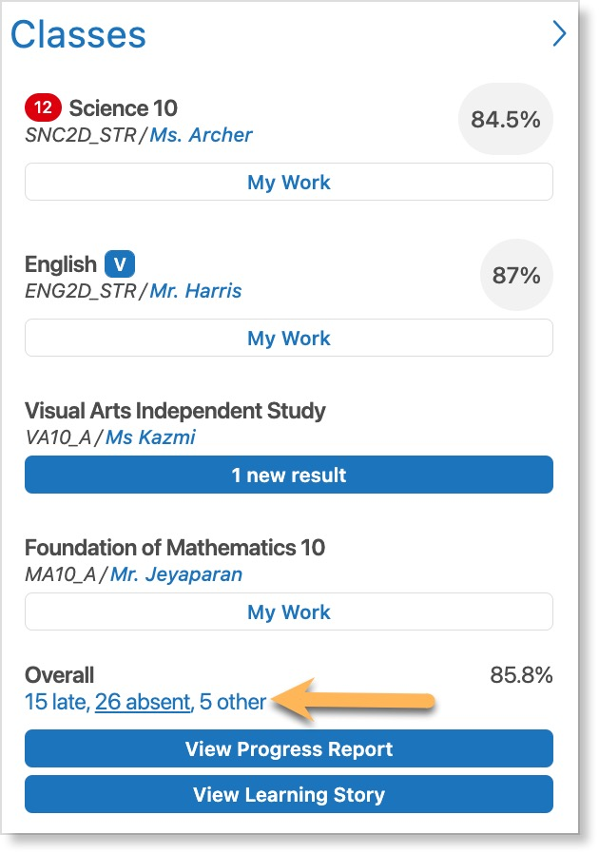
  - Panorama
Clicking on a student’s name anywhere in Edsby opens the student’s Panorama.

The Panorama includes the Attendance Summary Report of a student as seen in the Students Zoom and Year Calendar View of the Attendance Zoom’s Student Tab.

Click on the Attendance Totals at the bottom of the Classes Panel to view it.

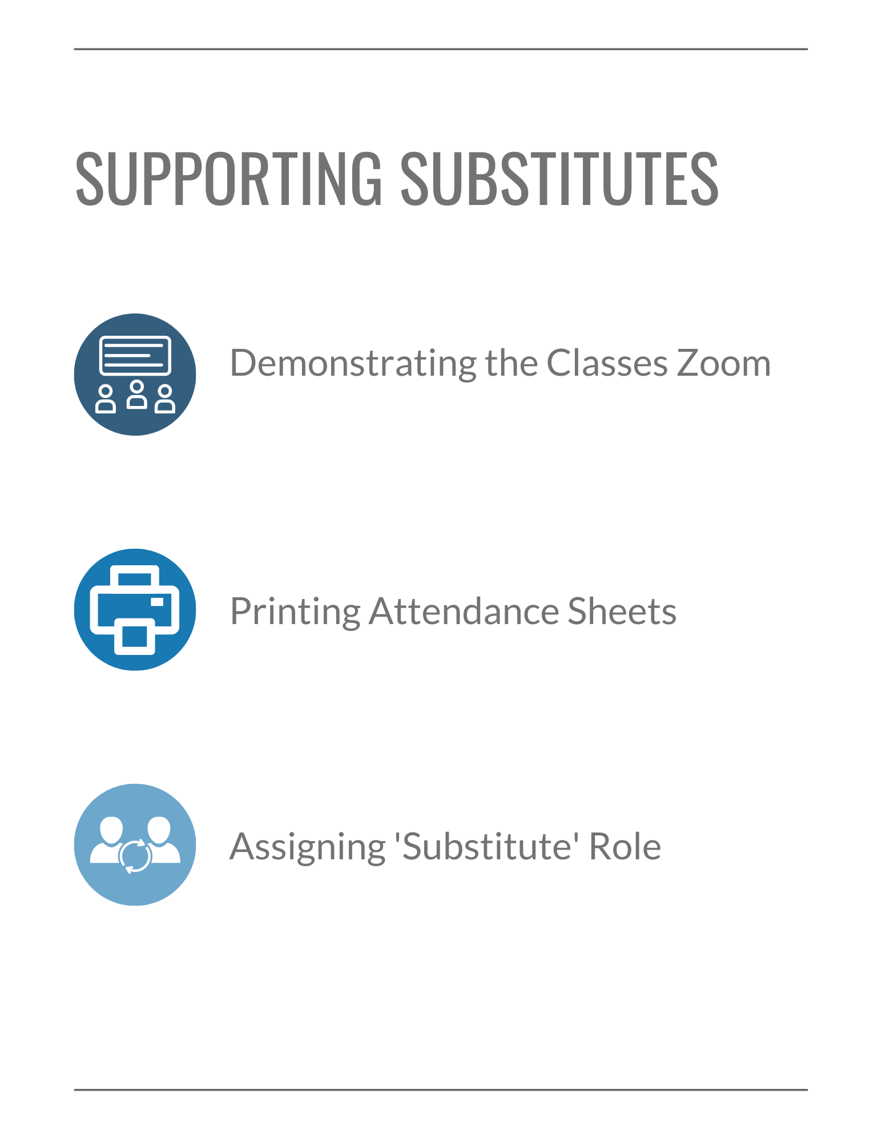

Supporting Substitute Teachers

The Classes Zoom
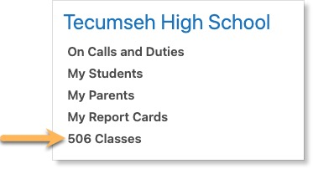
Teachers working at the same school can take attendance from the Classes Zoom. This section will help you teach your staff how they can take attendance for each other if needed.

The Classes Zoom is found on a teacher’s Home Screen. This lists all the Classes being taught at the school. Clicking on a class opens the Attendance Sheet.

Teachers can fill out the attendance and share it with the Office. The person who submits the attendance is listed on the Attendance Sheet.

Printing Attendance Sheets
There may be times when a substitute teacher may not be associated with the school. In this case, they will not have access to the Classes Zoom to take attendance and therefore, printing a Class List may be necessary.

Attendance Sheets can be printed in either the Attendance Zoom or Classes Zoom.

In the Attendance Zoom, navigate to the Attendance Sheets Tab. Type Ctrl + P to print the page.

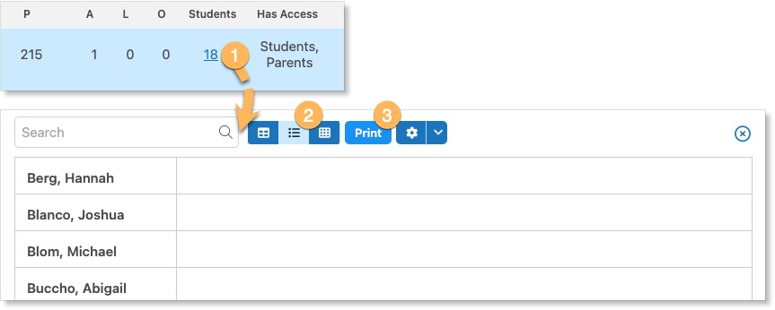

In the Classes Zoom, narrow down the Class that has the substitute. Click on the number of students to open the Class List. Select List View and Print.

Assigning a ‘Substitute’ Role
Substitute teachers can be assigned to a Class within Edsby. For example, if there is a specific teacher who often covers for another.
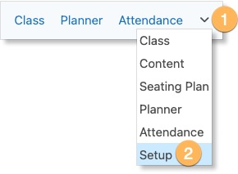

Open a Class and navigate to the Class Setup by clicking the drop-down arrow and selecting Setup.

Navigate to the Teachers & Assistants section. Type in the name of the substitute and assign them the Substitute role.

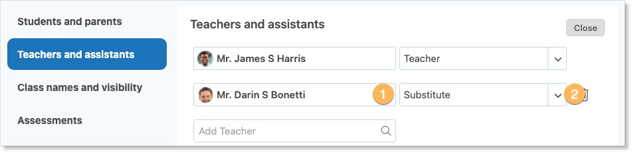

Substitute teachers have the most minimal Class access of any of the teacher roles. Their main role is to take Attendance. They can open the Attendance Sheet, mark students as Absent, Late, or Present, and can change any Attendance States.

We’ve covered it all! Review the checklist to make sure you feel comfortable completing all of the core Edsby skills for the Attendance Office.

Navigate Attendance Zoom
I can navigate to the Attendance Zoom.
I can use filters and search to narrow down Attendance Zoom info.
I can navigate the four different tabs of the Attendance Zoom.
I can use Away Today, Planned Absence, Admit Slip, and Sign Out in the Student Tab.

Common Tasks
I can resolve both individual and multiple Attendance Incidents.
I can notify parents of Attendance Incidents.
I can issue Admit Slips for both individual and multiple students.
I can perform bulk actions on Attendance Sheets.
I can submit Attendance Sheets on behalf of a teacher.
I can export Attendance data.

Finding Attendance Info
I can view Attendance info in the Students Zoom and Student Report.
I can view a student’s Attendance Summary Report in the Panorama or Students Zoom.

Supporting Substitutes
I can navigate the Classes Zoom.
I can print Attendance Sheets.
I can assign ‘Substitute’ roles in an Edsby Class.

Help and Support Resources
There are many places where you can find support for any questions you may have about Edsby or to just learn more about the platform.

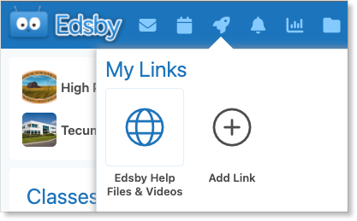
Launchpad
The Launchpad provides quick access to the support section of the Edsby website. Click Edsby Help Files & Videos for help using the Edsby platform.
Try adding your own links for quick access.

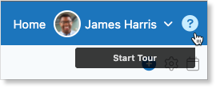
Edsby Tours
Click the question mark in the top right of any screen in Edsby to walk through a tour of the screen you are looking at. An optional overview video is provided as well.

Edsby Feedback Groups
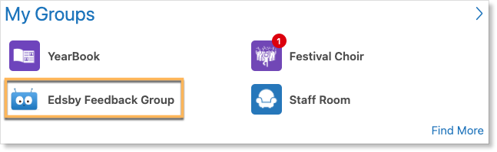
Every school or district is automatically enrolled in an Edsby Feedback Group. Both expert Edsby users and Edsby Customer Support Representatives monitor these groups to answer questions you may have. You may even be able to learn from other teachers in your school or district on how they like to use Edsby!

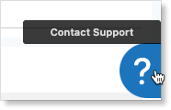
Edsby Customer Support
If you are unable to find the answer to your question through Edsby’s Help Files & Videos, you can click the question mark in the bottom right of any screen in Edsby to file a ticket with an Edsby Customer Support Representative.

