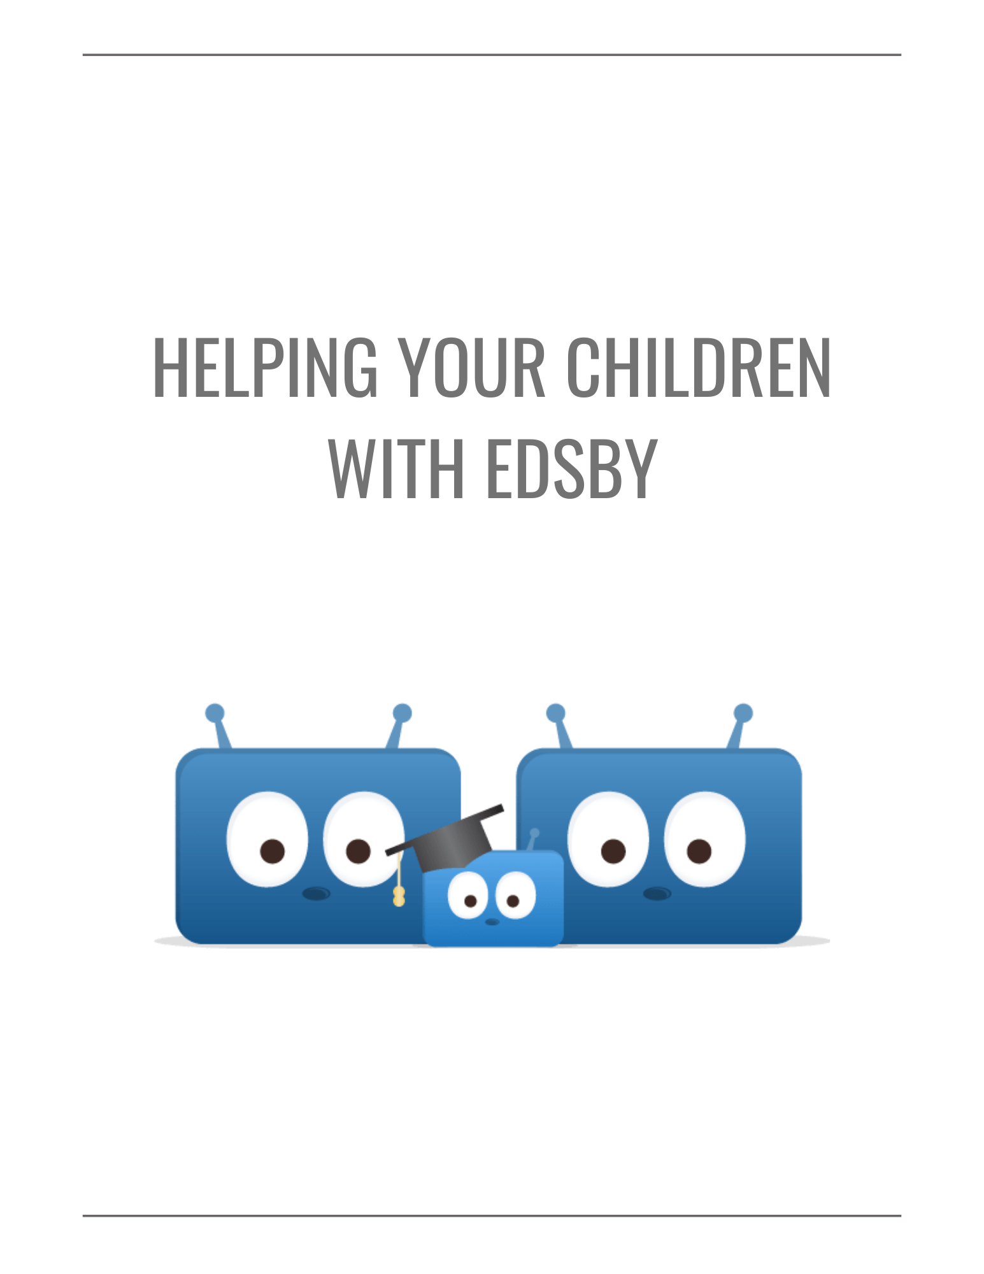
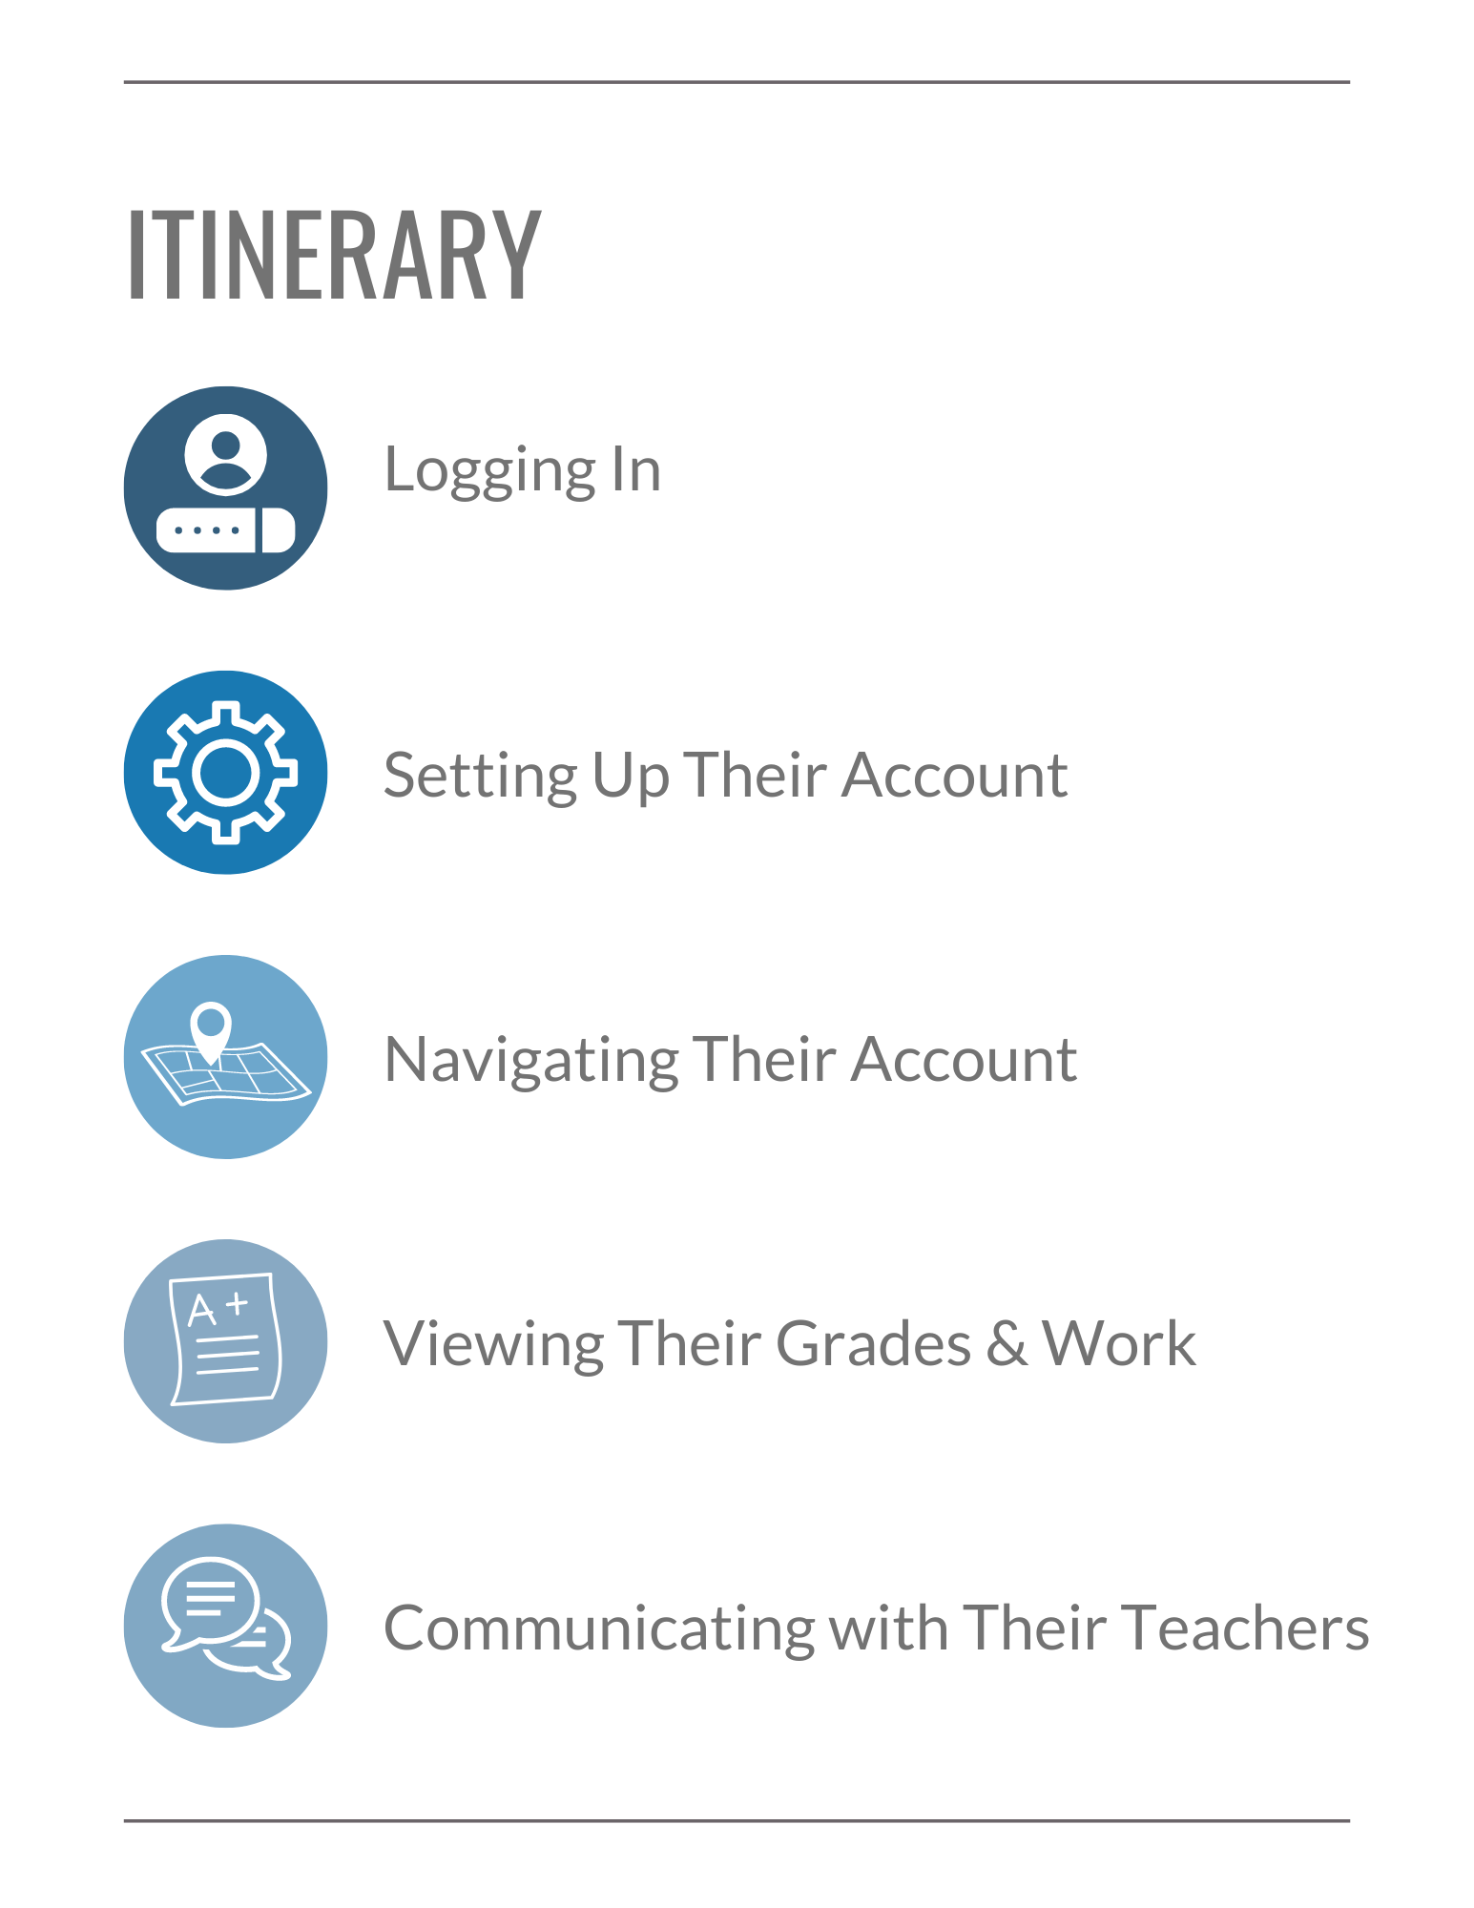

Checklist for your Children

In this session, we’ll be covering the core Edsby skills for you to help your children with. Your children can use this checklist to ensure they can use Edsby’s many features. Click the hyperlinks to jump to the part of the document where each skill is discussed.

Logging In
I can login to my Edsby account.

Setting up my Account
I can setup my Notifications.

Navigating my Account
I can navigate my Home Screen.
I can read articles in the News River.
I can view school information on the School Page.
I can navigate to my Classes and interact with the Class Feed.
I can view my Classes and upcoming assessments in my Calendar.

Viewing my Grades and Work
I can view my assessments and grades in my My Work Report.
I can view my shared Learning Evidence in my Learning Story.
I can view my Portfolio and make new posts.

Communicating with my Teachers
I can send messages to my teachers.
I can interact with posts in the Class and Recent Activity Feeds.

Logging In
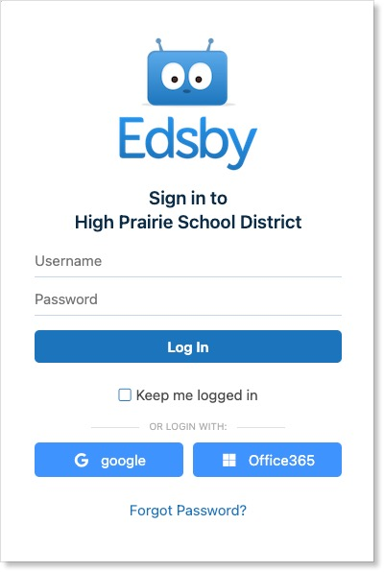
Just like when you login to Edsby, your children need to type in the correct Edsby server address for your school or district. Every Edsby system has a unique URL, like http://xxxx/edsby.com, where xxxx is unique to the school or district.

Ask the school for your system’s Edsby server address and direct your child there. Encourage them to bookmark it for easy access.

In addition to accessing Edsby through a desktop or mobile browser, your students can keep up-to-date with their schooling on their mobile device by using the Edsby Mobile App.

Show them how to download the app by directing them to either Google Play or the App Store. The server address for the app is the same as required on the browser.

If you or your children have additional questions about logging into Edsby, direct them to your school office.

Setting Up Their Account

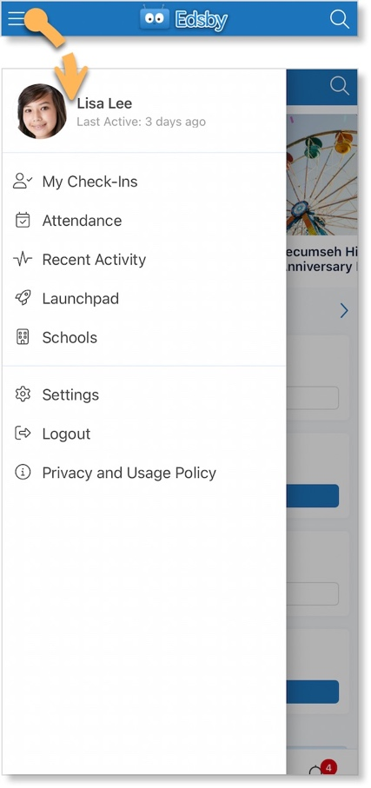
Notifications

With so many things happening inside Edsby, it is important to stay organized and up-to-date. Edsby makes this easy by enabling various notifications to ensure your children are notified of the important things happening within their school, Classes, and Calendars, as well as their own Groups.

Your children can access their Notification Settings by clicking the menu icon in the top left of their mobile Home Screen and selecting Settings.

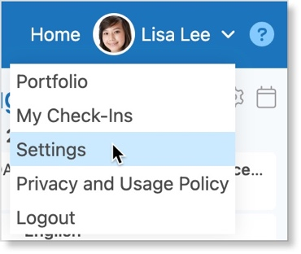

Or, if they are using a browser, they can access them by clicking the drop-down arrow next to their name and selecting Settings from the menu.

They will then select Notifications.

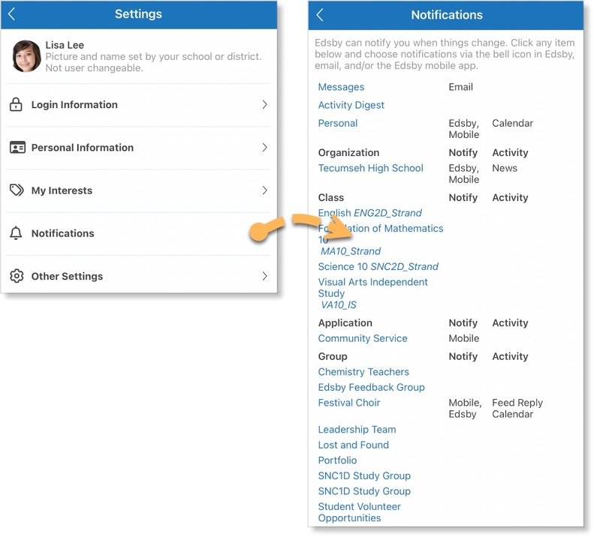

This provides your child with a form to select and update notifications regarding their own Personal Calendar, their school, Classes, and Groups.

They can choose to receive notifications through Email, Edsby itself, or straight to their mobile device.

A helpful resource on Notifications for Students can be found here.

Navigating Their Account
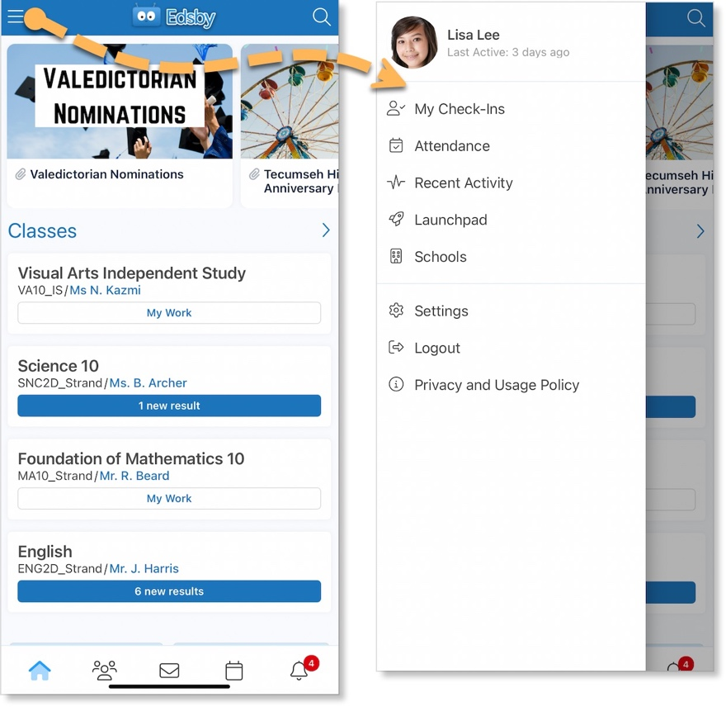
Home Screen

When students first login, their Home Screen is the first thing they see. This screen displays the News River as well as options to access their Classes Panel, Portfolio, Learning Story, and Groups.

Clicking the menu icon in the top left corner of their mobile Home Screen opens additional options.

As seen before, they can access their Settings from here as well as Attendance information, their Recent Activity Feed, Launchpad, and Schools. Your children will logout of the app from this menu.

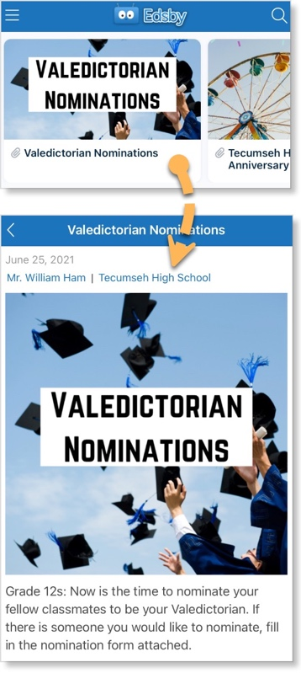
News River

The News River at the top of the Edsby Home Screen provides your children with the news regarding the school district and their school. This is a great way for your children to stay informed about everything happening at their school!

Scroll to navigate through the articles.

Clicking an article from the News River opens the full article.

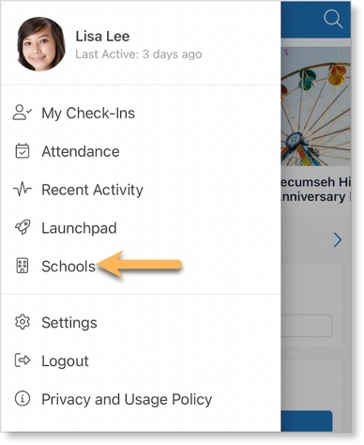
School Information

Your children can access the school and district pages by clicking the menu in the top left of their mobile Home Screen and selecting the name of the school or district.

Your children can scroll to view all school news posts.

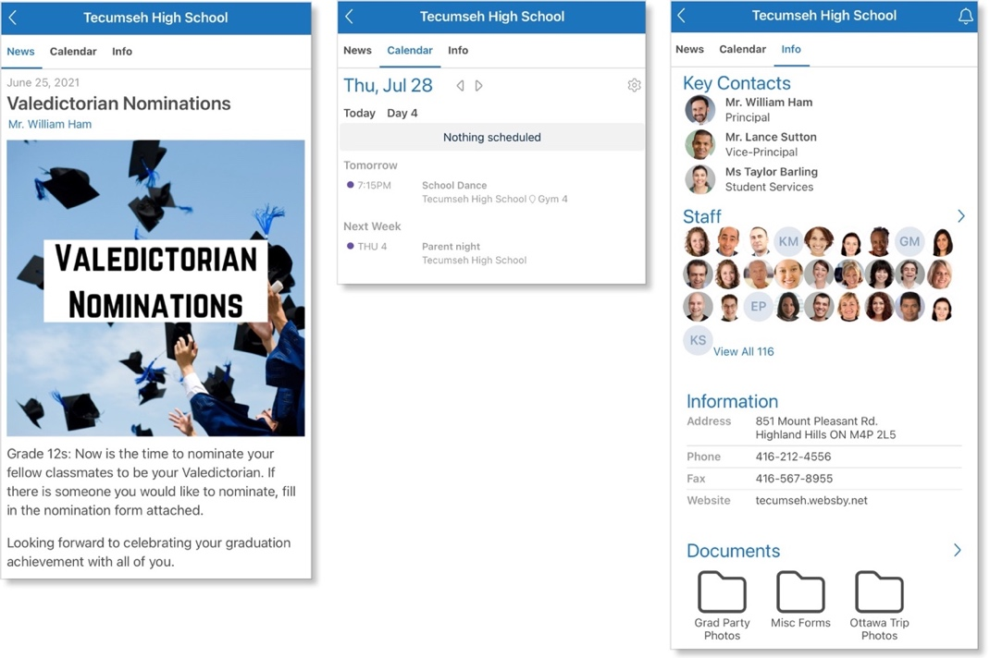
Clicking Calendar opens the school Calendar for your children to view.

Clicking Information opens important school information for your children to view including:

- Key Contacts in the school

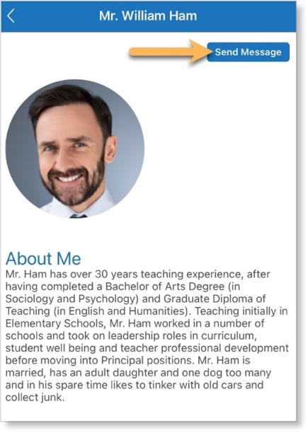
- Staff Panel, making it easier to contact any teacher or principal at the school through Edsby

- Contact Information for the school

- A school-wide Documents Library

Your children can quickly message any of the Key Contacts in Edsby by clicking their name, opening their mini-profile, and clicking Send Message
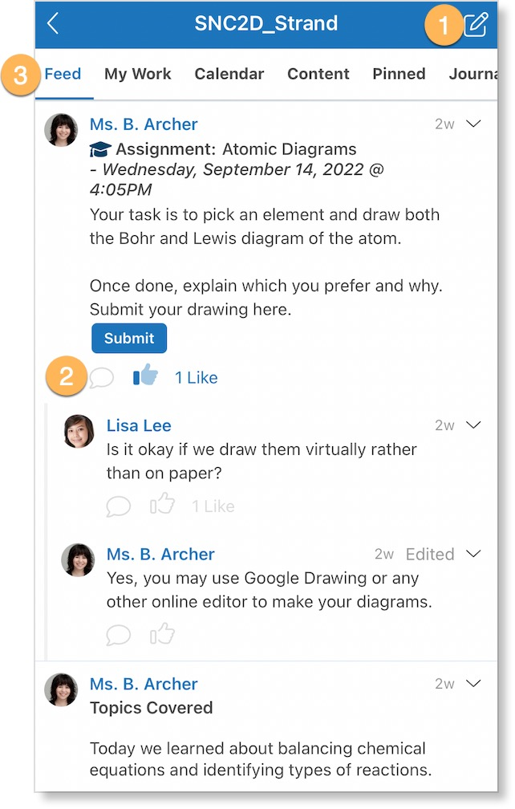
Classes

Your children can view the Classes they are enrolled in as well as their current averages if their teacher has chosen to share them, on their Home Screen Classes Panel both on browser or mobile.

They will click a Class to enter it.

Once inside the Class:

- Show them how to create a post using the icon in the top right corner if their teacher has enabled students to post.

- They can like and reply to posts in the Class Feed using the icons under each feed post. This is a great way for them to collaborate with their teacher and classmates!

- Show your children how to access various aspects of the Class like their My Work, Calendar, Content, Pinned Items, Journal, and Library, using the scrolling top menu.

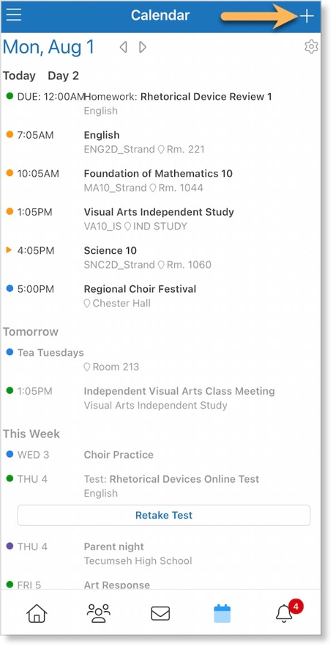

Student Calendars

The events and assessments of all Classes and Groups your children are part of are merged on their Personal Calendar. This Personal Calendar is accessible to them by clicking the Calendar icon in their bottom mobile Navigation Bar.

Or on a browser, it is visible on the right side of their Home Screen.

Encourage your child to use this Calendar to keep track of their due dates, events, and other activities and practice time management. They can even add their own personal events by clicking the blue +.

Viewing Their Grades and Work

My Work Report

Students can view their assessments and grades if their teacher has shared them, in their My Work Report. This report is accessed by clicking the My Work or New Results button on the Home Screen Classes Panel or by clicking My Work in the top header once inside a Class for both browser and mobile.

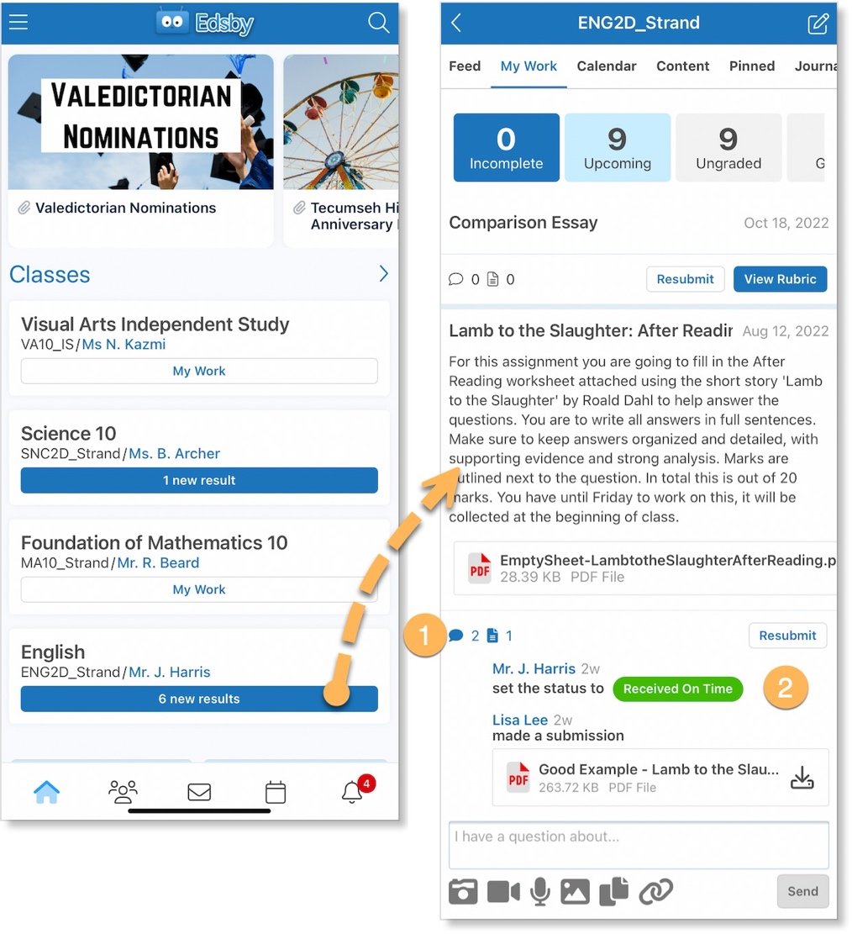

- If your child has a question about an upcoming or graded assessment, they can ask it easily through My Work by clicking the speech bubble icon.

- They can view any changed grades or responses to questions by clicking the assessment and viewing its details.

More information on the My Work Report for students can be found here.

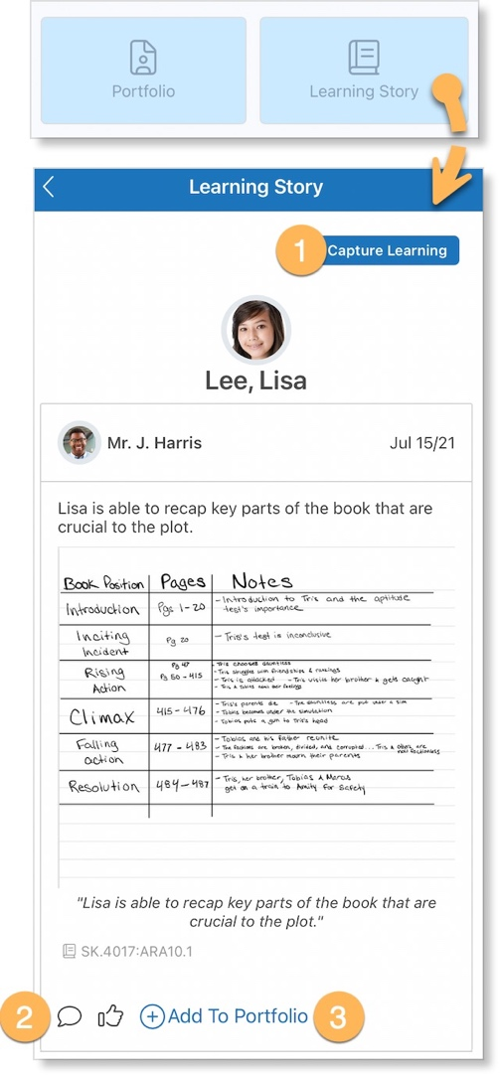
Learning Story

Edsby provides teachers with tools to capture Evidence regarding student learning. Once captured, teachers can share the Evidence with you and your children in their Learning Story.

Your children can view their Learning Story on mobile by clicking Learning Story under their Classes Panel on both their mobile and browser Home Screens.

- Show your children how they can capture their own Evidence by clicking Capture Learning in the top right corner.

- Show your children how they can like and comment on any posts in the feed and communicate with their teachers about each item of Evidence.

- They can also add Evidence to their Portfolio by clicking Add to Portfolio.

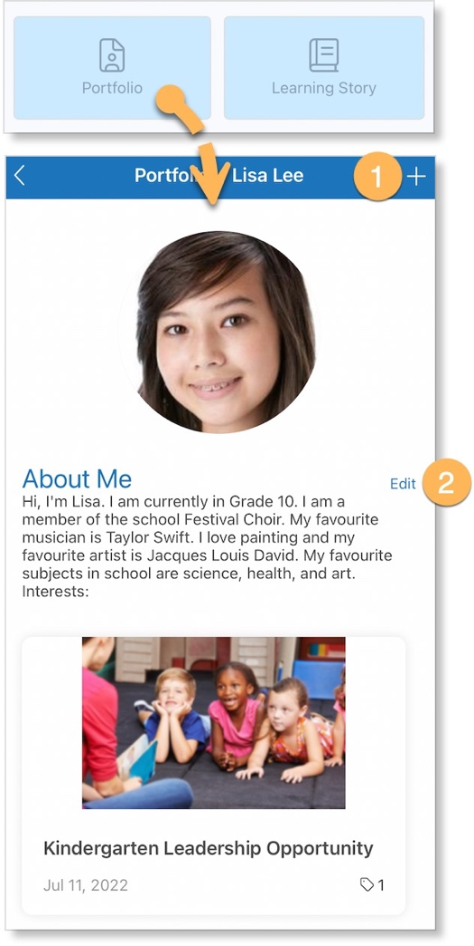

Portfolio

In your child’s Portfolio, they can create posts about themselves and their academic or extracurricular success.

They can view their Portfolio as a feed by clicking Portfolio under their name on their mobile Home Screen or in its full tile version on browser by clicking Portfolio under their Home Screen Classes Panel.

- Show your children how they can add posts to their Portfolio by clicking the + in the top right corner.

- And how they can edit their About Me by clicking Edit.

Communicating with Their Teachers

Messages

There may be times when your children want to message one of their teachers. Edsby makes this easy with Edsby Messages.

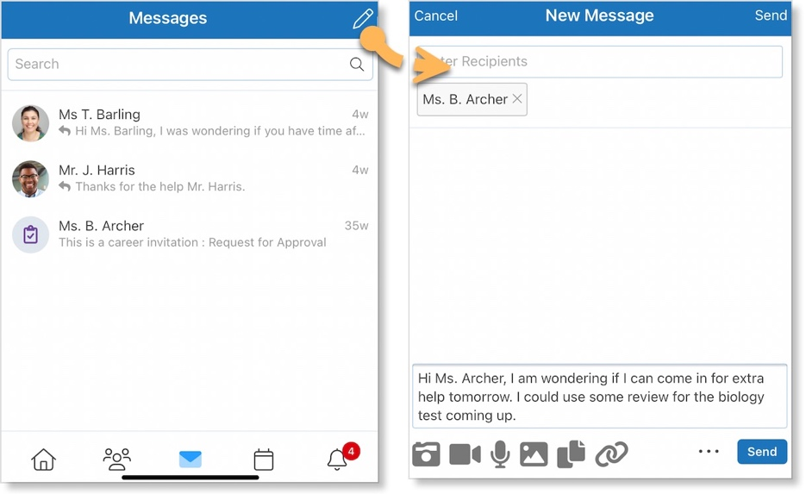
Your children have a mailbox available by clicking the envelope icon in their mobile Navigation Bar.

Here they can view previous conversations as well as compose a new message by clicking the icon in the top right.

Show them how to type in their teacher’s name in the recipient box and how to attach any files, if desired.

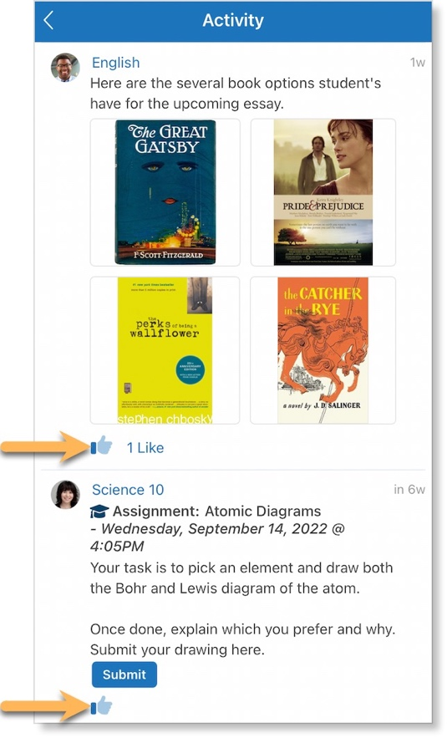
Interacting with Posts

If teachers have enabled students to enter the Class and participate, the best thing for your child to do is like and reply to teacher posts in the Class Feed.

They can also interact with posts in their Recent Activity Feed found on their main browser Home Screen or by clicking the menu icon in the top left corner of their mobile Home Screen and selecting Recent Activity.

We’ve covered it all! Have your children review the checklist to make sure they feel comfortable completing all of the core Edsby skills for students.

Logging In
I can login to my Edsby account.

Setting up my Account
I can setup my Notifications.

Navigating my Account
I can navigate my Home Screen.
I can read articles in the News River.
I can view school information on the School Page.
I can navigate to my Classes and interact with the Class Feed.
I can view my Classes and upcoming assessments in my Calendar.

Viewing my Grades and Work
I can view my assessments and grades in my My Work Report.
I can view my shared Learning Evidence in my Learning Story.
I can view my Portfolio and make new posts.

Communicating with my Teachers
I can send messages to my teachers.
I can interact with posts in the Class and Recent Activity Feeds.

Help and Support Resources
There are many places where you can find support for any questions you may have about Edsby or to just learn more about the platform.

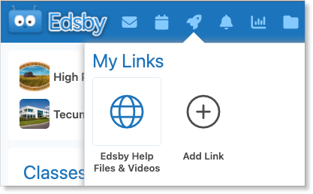
Launchpad
The Launchpad provides quick access to the support section of the Edsby website. Click Edsby Help Files & Videos for help using the Edsby platform.
Try adding your own links for quick access.

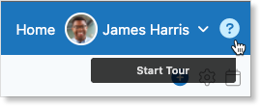
Edsby Tours
Click the question mark in the top right of any screen in Edsby to walk through a tour of the screen you are looking at. An optional overview video is provided as well.

Edsby Feedback Groups
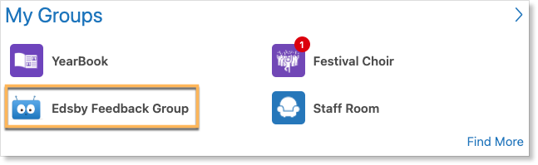
Every school or district is automatically enrolled in an Edsby Feedback Group. Both expert Edsby users and Edsby Customer Support Representatives monitor these groups to answer questions you may have. You may even be able to learn from other teachers in your school or district on how they like to use Edsby!

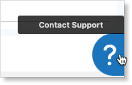
Edsby Customer Support
If you are unable to find the answer to your question through Edsby’s Help Files & Videos, you can click the question mark in the bottom right of any screen in Edsby to file a ticket with an Edsby Customer Support Representative.

