In this session, we’ll be covering the core Edsby skills for Office and Senior Administration. Click the hyperlinks to jump to the part of the document where each skill is discussed.

**Managing the School**

|  |  |
| --- | --- |
|  | I can use Edsby Zooms to find important school information. |
|  | I can export Zoom data. |
|  | I can manage notifications in the Office. |
|  | I can navigate to the School Page. |
|  | I can add staff to Key Contacts. |
|  | I can print a Staff List. |
|  | I can set staff Roles. |
|  | I can access and create school Report Card Comments. |
|  | I can access Staff Details and view any history of changes to the information. |
|  | I can use Approvals to request student or parent permission. |
|  | I can navigate the Report Card Process within Edsby. |
|  | I can use Edsby Usage Dashboards for insight into the school’s Edsby usage. |
|  | I can create and use Professional Development Groups for teacher training. |

**Communicating with the School Community**

|  |  |
| --- | --- |
|  | I can add a news article to the school News River. |
|  | I can add an event to the school Calendar. |
|  | I can send messages to others in the school through my Edsby Mailbox. |

**Monitoring Student Progress**

|  |  |
| --- | --- |
|  | I can use the Students Zoom to find important student information. |
|  | I can print Progress Reports from the Student Zoom. |
|  | I can navigate to the Student Report. |
|  | I can view important student information in the Panorama. |
|  | I can view a student’s Attendance Summary Report. |
|  | I can view a student’s academic progress for each class in their My Work Report. |
|  | I can create and use Monitor Groups. |

**Collaboration within the School**

|  |  |
| --- | --- |
|  | I can create and use Edsby Groups for collaboration. |
|  | I can create and use Professional Development Groups. |

**Parent Onboarding & Management**

|  |  |
| --- | --- |
|  | I can navigate and facilitate the Parent Invitation Process. |
|  | I can monitor parent engagement within Edsby. |
|  | I can create and manage Parent-Teacher Interview Schedules. |

**Managing the School**

Zooms

Edsby Zooms are powerful data analysis tools designed to help you manage the school by providing valuable information about people, Classes, rooms, and Groups in the school.

Each Zoom provides a list view of data.

These lists can be easily sorted by clicking on the column headers or using the filters.

You have access to 7 main Zooms on your Home Screen:

Students, Staff, Parents, Student Contacts, Classes, Groups, and Rooms.

|  |  |
| --- | --- |
|  | **Students Zoom**  A list of all students in the school and information pertaining to them including name, grade, risk indicators, attendance information, and parent activity. |
|  | **Staff Zoom**  A list of all staff members in the school and information pertaining to them including their role, title, current location, and the Classes they teach, if any. |
|  | **Parents Zoom**  A list of all parents and guardians associated with students at the school as well as information about them including their name, contact information, which students they are linked to, and the time of their last login to Edsby. |
|  | **Student Contacts Zoom**  A list of all contacts associated with students in the school like parents, guardians, doctors, or babysitters. You can invite parents and guardians to activate their Edsby account from here. |
|  | **Classes Zoom**  A list of all Classes being taught in the school and information about them including the Class name, grade, subject, teacher, number of students, and who has access to the Class. |
|  | **Groups Zoom**  A list of all Groups created at the school and information about them including the name, type, membership style, visibility settings, number of members, and how many posts have been made in the Group. |
|  | **Rooms Zoom**  A list of all rooms in the school and information about them including their occupancy, room number, capacity of the room, room type, and whether the room is currently in use. |

Activity – Exporting Zoom Data

The information found in each Zoom can be exported into a csv file. This file can then be opened with a variety of spreadsheet, database, or word-processing software.

To export the Zoom information:

1. Filter to the desired subset of data.
2. Click the drop-down arrow at the top right of the Zoom.
3. Select *Export* from the menu.

[More information on Edsby Zooms can be found here.](https://edsby.com/help/zooms/?locale=en)

The Office

The Office contains notifications from the parent invitation process, changes to personal information, security notices for unauthorized login attempts, and reported inappropriate content.

Any posts that have been reported as inappropriate are visible for you to review and if necessary, delete from their posted location.

The Office link can be found on the right side of your Home Screen with a red counter to indicate the number of new unread notifications.

[More information about the Office’s functionality can be found here.](https://edsby.com/help/administrator-quick-start/the-office/?locale=en)

The School Page

The School Page, accessed from the top left of your Home Screen, provides a great way for you to share a wide range of school-specific information including:

1. Key Contacts of the school
2. A list of Staff members in the school
3. An Important section for teams, clubs, staff members, etc.
4. School News articles
5. School Calendar
6. School Information including its address, phone numbers, and fax numbers
7. Documents such as newsletters, handbooks, or a school form

Activity – Adding Staff to Key Contacts

To add Staff to Key Contacts, open the Staff pop-out and click *Add to Key Contacts.*

The order of the Key Contacts panel can be changed by clicking and dragging Contacts to a new location.

[More information on the School Page can be found here.](https://edsby.com/help/administrator-quick-start/the-school-page/?locale=en)

Activity – Printing a Staff List

With the Staff pop-out open, you can print a Staff List.

1. Change the layout to one of two list views by clicking the icons at the top right of the pop-out.
2. When ready, click *Print*.

Activity – Setting Roles

Edsby has a set of roles that control what each staff member can see and do in Edsby. Some Student Information Systems provide Edsby with a SIS role for each staff member and Edsby automatically maps them to an Edsby role. In this case, you will need to verify the roles are correct. However, if Edsby is not provided with roles from the SIS, it will default all staff members to the role of Teacher.

If changes need to be made, open the Staff pop-out and select the specific staff member to open their Teacher Details page.

Click *Information*. In the User Type field, select the appropriate role and Save.

Activity – School Report Card Comments

School-level Report Card comments can be managed within Edsby by clicking Comments at the top right of the School Page.

New Comments can be created here by clicking *Add New Comment* and filling out the form.

Comments can also be imported from a csv file. The best way to ensure you are using the correct format to import comments into Edsby is to create a comment within Edsby and then export it.

[More details on creating Report Card Comments can be found here.](https://edsby.com/help/administrator-quick-start/adding-district-level-school-level-report-card-comments/?locale=en)

Staff Details

The Staff Details page, as seen when setting Roles, is accessed by clicking a staff member’s name anywhere in Edsby. The page displays all information imported from the Student Information System about a given staff member including any Classes they teach, contact information, username, and account activity.

The page also includes options to suspend the staff member’s account, reset their password or view Account History. Clicking *Show History* displays any changes made by the SIS as well as manual changes to a staff member’s Account Settings.

Approvals

Field trips, school opportunities, and requests for volunteers are all simplified using Edsby Approvals. Approvals enable you to send requests directly to parents and students and receive a list of responses as soon as they respond.

Navigate to the Students Zoom and use the filters to specify the list of who you want to send Approval requests to. Once selected, click the drop-down and select from either requesting parent or student permission.

Customize the message and response options. When ready, send the requests.

Parents and students receive permission requests directly as a message in their mailbox.

1. Graphical user interface, text, application

   Description automatically generatedYou will receive responses to the requests in your mailbox.
2. As soon as a parent or student responds to the request, the workflow will be updated in your mailbox.
3. A hard copy of the request can be printed.

[Additional information about the Approval process can be found here.](https://edsby.com/help/a-guide-for-teachers/approvals-2-2/?locale=en#:~:text=Edsby%20approvals%20enable%20teachers%20to,are%20kept%20secure%20within%20Edsby.)

Report Cards

As an administrator, you have access to the Report Cards Zoom. This Zoom appears when the first reporting period is created. Report Cards can then be printed directly from within Edsby or by exporting data to another system. Report Cards can also be published and made available to students and parents on their Edsby Home Screens.

To create a reporting period, use the Classes Zoom. Filter to the Classes you wish to use. Select *Add to Report Card* from the drop-down menu.

Now you can manage the reporting period through the Report Cards Zoom.

The Report Card Zoom has two tabs: Sheet View and Student View.

Sheet View lists all Report Card sheets for each reporting period. Review submitted sheets and approve them or return for correction by clicking a sheet and selecting an option.

Student View lists all students included in each reporting period. This tab is used for printing Report Card Sheets. Use the filters to navigate to the set of sheets you wish to print. Click *Print*.

Report Cards can also be published for viewing within Edsby by students and their parents. As soon as one Report Card Sheet is submitted, the Publish button will appear in Sheet View of the Report Cards Zoom.

Clicking *Publish* will publish all submitted and approved sheets.

Students and parents can view the Report Card by clicking the *View Report Cards* button at the bottom of the Home Screen Classes Panel.

[More information about managing Report Cards can be found here.](https://edsby.com/help/administrators/report-card-creation-and-management/)

Edsby Analytics

Edsby Usage Dashboards are analytical tools built right into Edsby that provide insight into overall Edsby Usage across a district as well as per-school dashboards that provide insight for each school in the district. These dashboards are available at the bottom of your Home Screen below Recent Activity.

The default view shows the total number of unique users active in Edsby over the previous week.

1. Hover over a section of the graph to display additional details.
2. For a more detailed view on the school’s Edsby Usage, click the *Edsby Usage* Link in the upper left corner of the initial dashboard
3. Or click the *dashboard* button in the top right. Additional dashboards are displayed including feature usage dashboards.

[More information about using Edsby Usage Dashboards and Edsby Analytics can be found here.](https://edsby.com/help/principal-and-senior-administrator-quickstart/edsby-usage-dashboards/?locale=en#:~:text=The%20full%20view%20of%20the,full%20page%20Edsby%20Usage%20view.)

Teacher Training

With Edsby’s wide selection of purpose-built tools, teachers often benefit from training that shows them all Edsby’s capabilities. You can use Professional Development (PD) Groups for self-paced training material that informs and shows teachers everything they can do in Edsby.

Create a PD Group by clicking *Find More* in your Home Screen My Groups Panel. Click *Create* and select Professional Development Group as the type. You can use automated membership to enroll teachers in the Group.

PD Groups function similarly to other Edsby Groups but include a Content Builder that enables moderators of the Group to add rich content including images, PDFs, links to videos, pages, and access to a rich text editor. This functionality makes them perfectly suited for creating training material.

To add rich content to the Group, click *Content*, then *Edit*. Add sections, pages, links, and files to the Group by clicking the + next to the Group name. Consider creating sections that instruct teachers in the fundamentals of using Edsby in their classrooms like *Setting Up Edsby, Creating Content in Your Class,* and *Assessing Student Performance.*

It’s also a great idea to provide a link to the teacher support section of the Edsby website.

PD Groups enable you to view which teachers have been viewing and interacting with the Group’s Content by clicking *Show Progress*.

[For more information on using PD Groups for teacher training, click here.](https://edsby.com/help/principal-and-senior-administrator-quickstart/training-teachers-through-pd-groups/)

**Communicating with the School Community**

School News

In Edsby, schools and districts can publish news to the News River. When individuals login to Edsby, they will see the News River at the top of their Home Screen with news relevant to the schools and district they are associated with.

Activity – Adding a News Article to the News River

To add an article to the News River, navigate to the School Page and click *Submit an Article.*

1. Fill in the form with a title, content, and image.
2. Attachments are optional.
3. Click Submit.

The article is added to the School Page pending approval. Until approved, the article is only visible to you.

**Note:** Staff and students can submit article, however, only you can approve them.

1. Use the buttons at the bottom of the article to Edit or Unapprove it.
2. Click the gear icon to set a Show or Expire date.

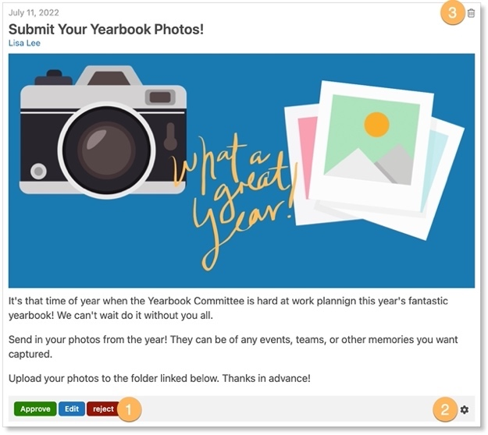

1. To delete a news article, click the trashcan icon that appears.

[More information about managing the News River can be found here.](https://edsby.com/help/administrators/managing-the-news-river/)

School Calendar

The School Calendar is used to create school-wide events. Holidays, PD Days, and school breaks are added automatically when Edsby is first set up.

However, you can add additional school-wide events easily through the Calendar on the School Page. These events will appear on everyone’s Home Screen Calendar in Edsby with a purple dot beside them.

Click the Calendar icon on the School Calendar to open the full Calendar.

Activity – Adding an Event to the School Calendar

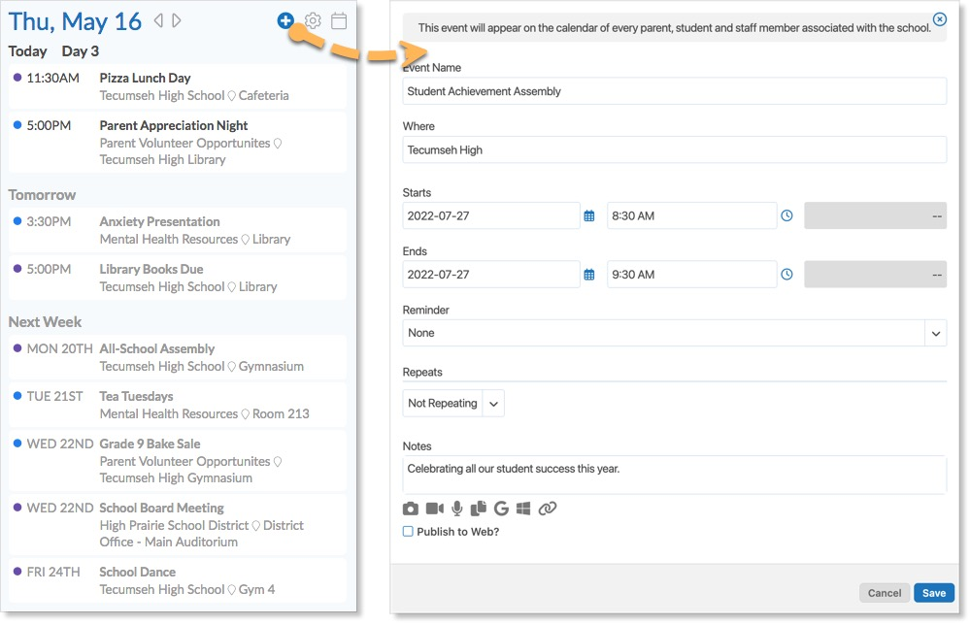To add a new event to the School Calendar:

1. Click on the blue plus icon to open the New Event form.
2. Fill in the New Event form.
3. Click Save.

The event will be added to the Home Screen Calendars of everyone associated with the school.

Messages

Edsby Messages can be used to communicate privately between individuals within the school. You can message students, staff members, and parents.

Access your messages by clicking the envelope icon in the Navigation Bar.

New messages are created by clicking the compose icon in the inbox and typing the recipient’s name in.

While the News River, School Calendar, and Edsby Groups are the best way to communicate with the entire school community, you can also send bulk messages to groups of individuals at your school. Messaging students and parents is done through the Students Zoom, messaging a group of staff members is done through the Staff Zoom, and messaging members of particular Groups is done through the Groups Zoom.

1. Filter the list as necessary.
2. Click the gear icon.
3. Select which people to message.
4. Click the drop-down arrow and select who to message.

**Monitoring Student Progress**

Senior administrators work with teachers and other staff members to monitor and promote student success within the school.

Students Zoom

The Students Zoom provides you with a list of all students in the school and information pertaining to them including their current Class, risk indicators, their current average, and their total number of absences and lates in the current term.

Risk indicators help you identify students who may be struggling at school. These include:

1. Failing Classes
2. Receiving a low subjective performance indicator
3. Repetitive lates or absences.

The Students Zoom filters can be used to narrow down the students.

1. You may be interested in filtering the list to students with a failing average or on the verge of failing.
2. Find students with high absenteeism by clicking on the Attendance column headers to sort.
3. You can also view when students and their parents were last active in Edsby.

[More information about the Students Zoom can be found here.](https://edsby.com/help/zooms/zoom-students/?locale=en)

Activity – Printing Progress Reports

Edsby enables you to view and print Progress Reports. These can be beneficial when setting up a meeting with students and their parents.

Select which students to print Progress Reports for by clicking the gear and selecting the checkboxes.

Click the drop-down arrow and select *Progress Report*.

The Progress Report provides a printable report summarizing each student’s Classes as well as their average, attendance totals, and subjective performance indicator for each Class.

[Additional information about printing Progress Reports can be found here.](https://edsby.com/help/gradebook-2-3/gradebooks-class-specific-progress-alerts/?locale=en)

Student Report

1. Once in the Students Zoom, you can navigate to the Student Report by clicking the link at the top. This provides you with valuable attendance data and information specific to each Class a student is enrolled in.
2. The data here can be exported by clicking the drop-down arrow and selecting *Export.*
3. The Student Report has two tabs: Classes and Groups.

The default is the Classes Tab which generates a line for each student’s Classes, shown above. Important information here includes the student’s attendance totals and average specific to each Class.

The Groups Tab generates a line for each group each student is a member of and information pertaining to each.

The Panorama

The Panorama provides you with the information you need to plan for student success. It is a secure area, only available to teachers and administrators. Here, you can see everything Edsby knows about the student.

1. View the Classes the student is enrolled in along with their current averages and subjective performance indicators in the Classes Panel.
2. View the student’s Progress Report and Learning Story from this panel as well. The Progress Report here provides a detailed breakdown of each of the student’s Classes.
3. At the bottom of the Classes Panel lists the student’s attendance totals. Click the totals to view the student’s Attendance Summary Report.
4. To understand a student’s current workload, review their schedule, assessments, and events located in the Calendar on the right side of their Panorama.

[More information about the Panorama can be found here.](https://edsby.com/help/panorama/?locale=en)

Activity – Viewing a Student’s Attendance Summary Report

View a student’s Attendance Summary Report by clicking their Attendance totals at the bottom of the Panorama Classes Panel. This report provides an overview of a student’s attendance history and includes a List View and Year Calendar View.

List View displays all attendance incidents associated with the given student.

Year Calendar View displays the student’s attendance history for the past year. This view enables you to identify any attendance issues.

My Work Report

You can view detailed information on a student’s progress in a Class with the My Work Report. Students have a My Work Report for each Class they are enrolled in.

Click the *My Work* or *New Results* button on the Panorama.

The Assessments tab is first shown. This provides a detailed breakdown of the student’s assessment results and upcoming assessments.

View a student’s academic progression in the Class by clicking the Graph tab.

The Expectations tab shows how a student is doing on each expectation/outcome for a Class, attendance incidents are listed in the Attendance tab, and previous report cards are visible through the Previous Report Cards tab.

[More information on the My Work Report can be found here.](https://edsby.com/help/class-panel/how-did-you-do-on-that-english-project-2/?locale=en)

Monitor Groups

After utilizing the Students Zoom and Panorama and observing the academic and attendance habits of students at the school, you will likely have a list of students you want to monitor and guide towards success. Edsby enables you to do just this with Monitor Groups.

Monitor Groups are used to monitor a list of students. However, students and their parents never see they are a member of a Monitor Group. Monitor Groups provide you, teachers, and other administrators with access to the Students Zoom information for a particular group of students to monitor and identify at-risk students based on attendance incidents or grades.

Inside a Monitor Group are two views: Tabular and Feed. Tabular View provides the Students Zoom information for the students in the Group.

1. The filters on the left side of the Group can be used to narrow the list of students down.
2. You can click the drop-down arrow and select from a menu of options including to message the parents, create a Planned Absence, or invite to a Group.
3. Students can be removed from the Group by clicking the trashcan icon in their row.

Feed View provides a classic group feed view. Here, moderators and other staff members in the Group can collaborate and discuss the students being monitored.

Monitor Group information can be exported for use in an external system through the Groups Tab of the Student Report as seen before by filtering to the Monitor Group and clicking Export.

**Note:** Teachers cannot create Monitor Groups – they can only be added. By default, teachers only have access to Classes Panel information of students they teach. However, if a teacher is added to a Monitor Group, they will have access to the information of the students in the Group, even if they don’t teach them.

Activity – Creating a Monitor Group

Create a Monitor Group by clicking *Find More* in your My Groups Panel and clicking *Create*.

1. Set the group type to Monitor Group.
2. It is recommended to keep the group as Private because they are not intended to be seen by students or parents.
3. Set the membership to Closed so only those added by you can be in the Group.
4. Click *Create Group*.

Identify the students you wish to add by using the Students Zoom.

When you are ready, navigate to the Monitor Group and click *Add Students.* Type in the names of the students and click Add Student.

[Additional information on creating and using Monitor Groups can be found here.](https://edsby.com/help/guidance-office-quickstart/monitor-groups/?locale=en#:~:text=Edsby%20Monitor%20Groups%20are%20used,a%20member%20of%20the%20group.)

**Collaboration within the School**

Edsby Groups

Edsby Groups are a powerful way for Groups of people to collaborate with each other in a convenient, secure, and effective way. Most schools using Edsby quickly end up with many Groups for sports teams, clubs, teacher professional development, or student council.

As part of every standard Edsby deployment, the following Groups are automatically set up:

|  |  |
| --- | --- |
|  | **School Talk**  Created at each school and includes all staff and students at the school. It provides a space where topics of interest can be discussed like upcoming events, sports team results, or school initiatives. |
|  | **Staff Room**  Created at each school and is only available to staff members at the school and provides a place for staff collaboration on matters they prefer not to share with students or parents. |
|  | **Edsby Feedback**  Created at the district level and all staff members in the district are added as members. This Group enables staff members to ask questions, report bugs, and provide feedback to the Edsby team. We try to respond to all posts the same day they are posted. |

You can request for these Groups to not be automatically set up. In addition to these Groups, consider creating the following Groups:

|  |  |
| --- | --- |
|  | **School Budget**  For school administrators to manage the school budget with other staff. |
|  | **Student Volunteer Opportunities**  For posting opportunities for students to gain leadership experience or community service hours. |
|  | **Semi-Formal Banquet**  For planning the school’s upcoming semi-formal banquet. |

Professional Development Groups

PD Groups were previously mentioned when discussing their use for teacher training, however, they can be used for a variety of professional development situations. Consider the following Groups:

|  |  |
| --- | --- |
|  | **Laboratory Training**  For science teachers to equip them in proper lab safety techniques. |
|  | **Anti-Bullying Awareness & Training**  For staff and students to raise awareness of school bullying and promote a safe school community. |
|  | **Information for Parents**  To display and broadcast important information to parents in the school. |

[Additional information on creating and managing PD Groups can be found here.](https://edsby.com/help/administrators/professional-development-groups/)

**Parent Onboarding & Management**

Parent Invitation Process

The Parent Invitation process within Edsby is designed to help the school district create Edsby accounts for parents by using information in the existing school databases. When the district is ready to invite parents to create an Edsby account, it is usually the office administration team that issues invitations from the Student Contacts Zoom.

The Student Contacts Zoom displays the up-to-date information about which parents have registered, have declined, or have invitations pending.

Parents can be reissued invitations or have their invitations revoked from the Student Contacts Zoom.

[Additional details about the Parent Invitation Process can be found here.](https://edsby.com/help/administrator-quick-start/parent-invitation-process-2/)

Monitoring Parent Engagement

You can use the Students Zoom to view which students have parents with active accounts. As well, information on when the parent or guardian last logged into Edsby is available here.

Hovering over a student’s name to view their Mini-Profile displays this information as well.

Parent-Teacher Interviews

Edsby’s Parent-Teacher Interview (PTI) process involves four key steps of creating a schedule, opening it to teachers, opening it to parents, and completing the bookings.

|  |  |
| --- | --- |
|  | **Create a Schedule/Edit**  You create a PTI schedule by choosing dates, times, and the length of the slot. After choosing which Classes are part of the schedule, the administrator opens the PTI schedule to teachers when ready. |
|  | **Open to Teachers**  Teachers block off slots they want to reserve for parents who may need additional time. |
|  | **Open to Parents**  You provide access to the parents. Parents receive an Edsby message alerting them that slots can now be booked. Parents can make their bookings and print out a summary list. If they have more than one child at the school, all students will appear on the same booking screen to assist with time management. Once open to parents, teachers and administrators can book appointments on behalf of parents. |
|  | **Complete**  When the school is ready to print the main list or complete other preparations, the administrator can close the schedule to parents. School administrators and teachers can continue to book appointments for parents. |

Activity – Creating a PTI Schedule

From the Home Screen, click *Parent-Teacher Interviews,* then *Create Parent-Teacher Interview.*

Enter the name of the schedule, the start date, and the end date. Click *Save.*

Once the schedule is created, slots are added to the schedule by setting the length of slots and amount of concurrent bookings for teachers.

Classes and Groups are added to the schedule through the Classes and Groups tab.

Open the schedule to teachers to manage their slots once Classes and Groups have been added. Once the schedule is open to teachers, no additional Classes and Groups can be added. Teachers can choose to block slots before parent booking has opened.

After teachers have had the opportunity to block slots, the schedule can be opened to parents. Once open, parents and guardians will receive a PTI workflow item in their Mailbox. Here they can book appointments with all the student’s teachers.

When you are ready to close the schedule to parent bookings, click *Complete* in the progress bar. Parents will no longer have access to booking or changing their appointment slots.

[More support for creating and managing PTI schedules can be found here.](https://edsby.com/help/administrator-quick-start/parent-teacher-interview-schedules/)

We’ve covered it all! Review the checklist to make sure you feel comfortable completing all core Edsby skills for the Office and Senior Administration.

**Managing the School**

|  |  |
| --- | --- |
|  | I can use Edsby Zooms to find important school information. |
|  | I can export Zoom data. |
|  | I can manage notifications in the Office. |
|  | I can navigate to the School Page. |
|  | I can add staff to Key Contacts. |
|  | I can print a Staff List. |
|  | I can set staff Roles. |
|  | I can access and create school Report Card Comments. |
|  | I can access Staff Details and view any history of changes to the information. |
|  | I can use Approvals to request student or parent permission. |
|  | I can navigate the Report Card Process within Edsby. |
|  | I can use Edsby Usage Dashboards for insight into the school’s Edsby usage. |
|  | I can create and use Professional Development Groups for teacher training. |

**Communicating with the School Community**

|  |  |
| --- | --- |
|  | I can add a news article to the school News River. |
|  | I can add an event to the school Calendar. |
|  | I can send messages to others in the school through my Edsby Mailbox. |

**Monitoring Student Progress**

|  |  |
| --- | --- |
|  | I can use the Students Zoom to find important student information. |
|  | I can print Progress Reports from the Student Zoom. |
|  | I can navigate to the Student Report. |
|  | I can view important student information in the Panorama. |
|  | I can view a student’s Attendance Summary Report. |
|  | I can view a student’s academic progress for each class in their My Work Report. |
|  | I can create and use Monitor Groups. |

**Collaboration within the School**

|  |  |
| --- | --- |
|  | I can create and use Edsby Groups for collaboration. |
|  | I can create and use Professional Development Groups. |

**Parent Onboarding & Management**

|  |  |
| --- | --- |
|  | I can navigate and facilitate the Parent Invitation Process. |
|  | I can monitor parent engagement within Edsby. |
|  | I can create and manage Parent-Teacher Interview Schedules. |

**Help and Support Resources**

There are many places where you can find support for any questions you may have about Edsby or to just learn more about the platform.

**Launchpad**

The Launchpad provides quick access to the support section of the Edsby website. Click *Edsby Help Files & Videos* for help using the Edsby platform.

Try adding your own links for quick access.

**Edsby Tours**

Click the question mark in the top right of any screen in Edsby to walk through a tour of the screen you are looking at. An optional overview video is provided as well.

**Edsby Feedback Groups**

Every school or district is automatically enrolled in an Edsby Feedback Group. Both expert Edsby users and Edsby Customer Support Representatives monitor these groups to answer questions you may have. You may even be able to learn from other teachers in your school or district on how they like to use Edsby!

**Edsby Customer Support**

If you are unable to find the answer to your question through Edsby’s Help Files & Videos, you can click the question mark in the bottom right of any screen in Edsby to file a ticket with an Edsby Customer Support Representative.