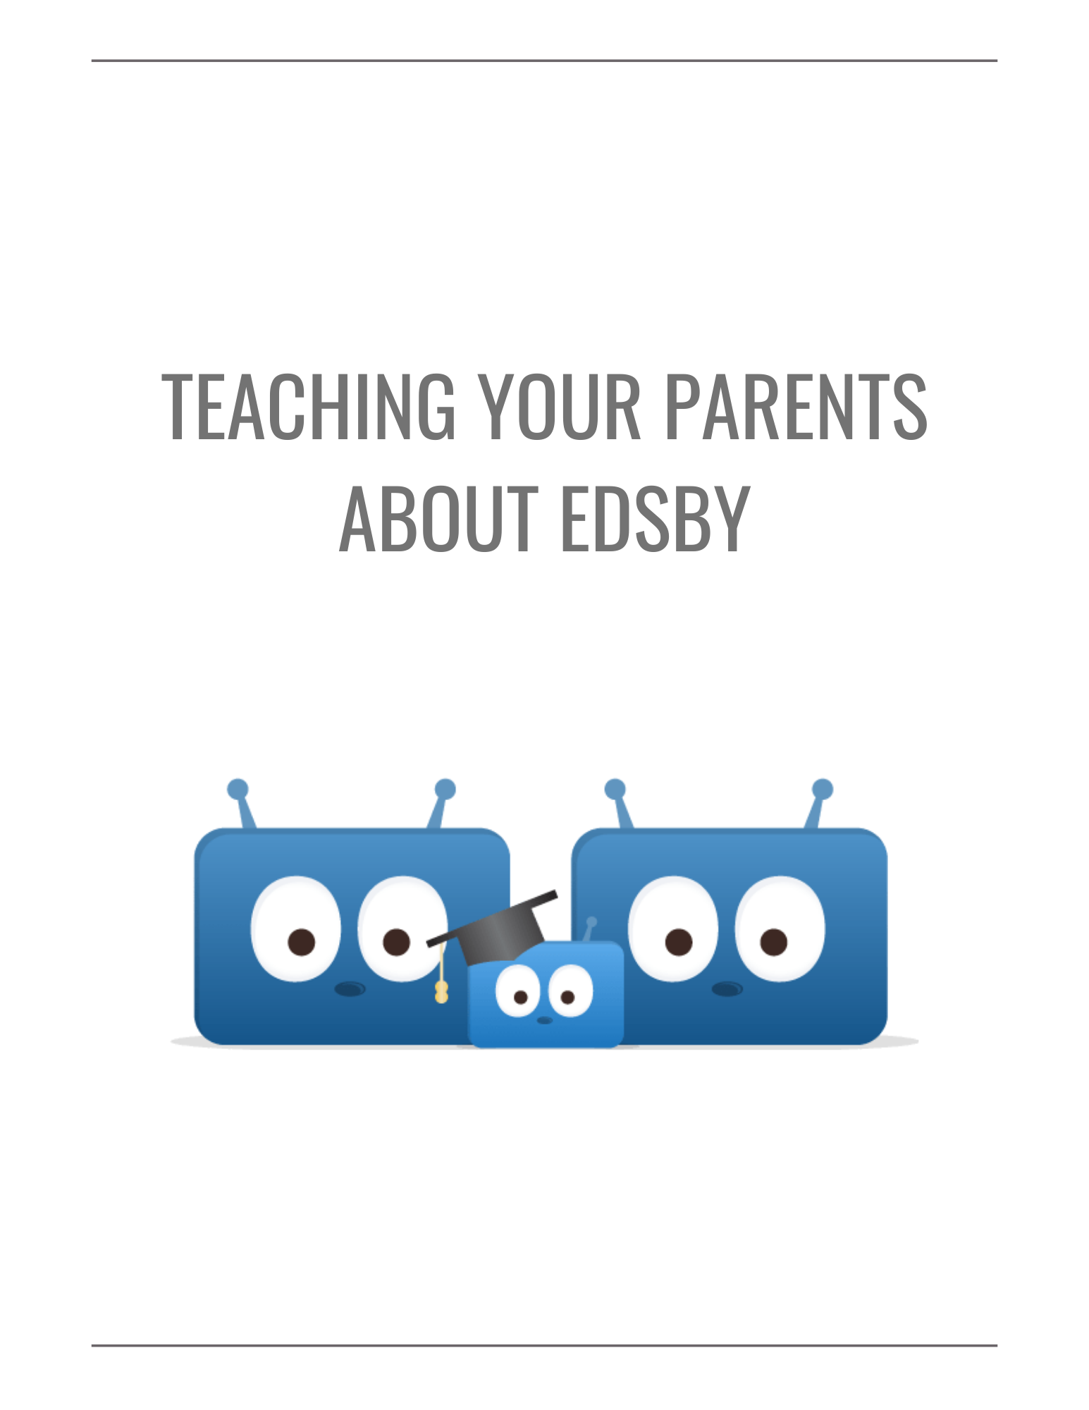
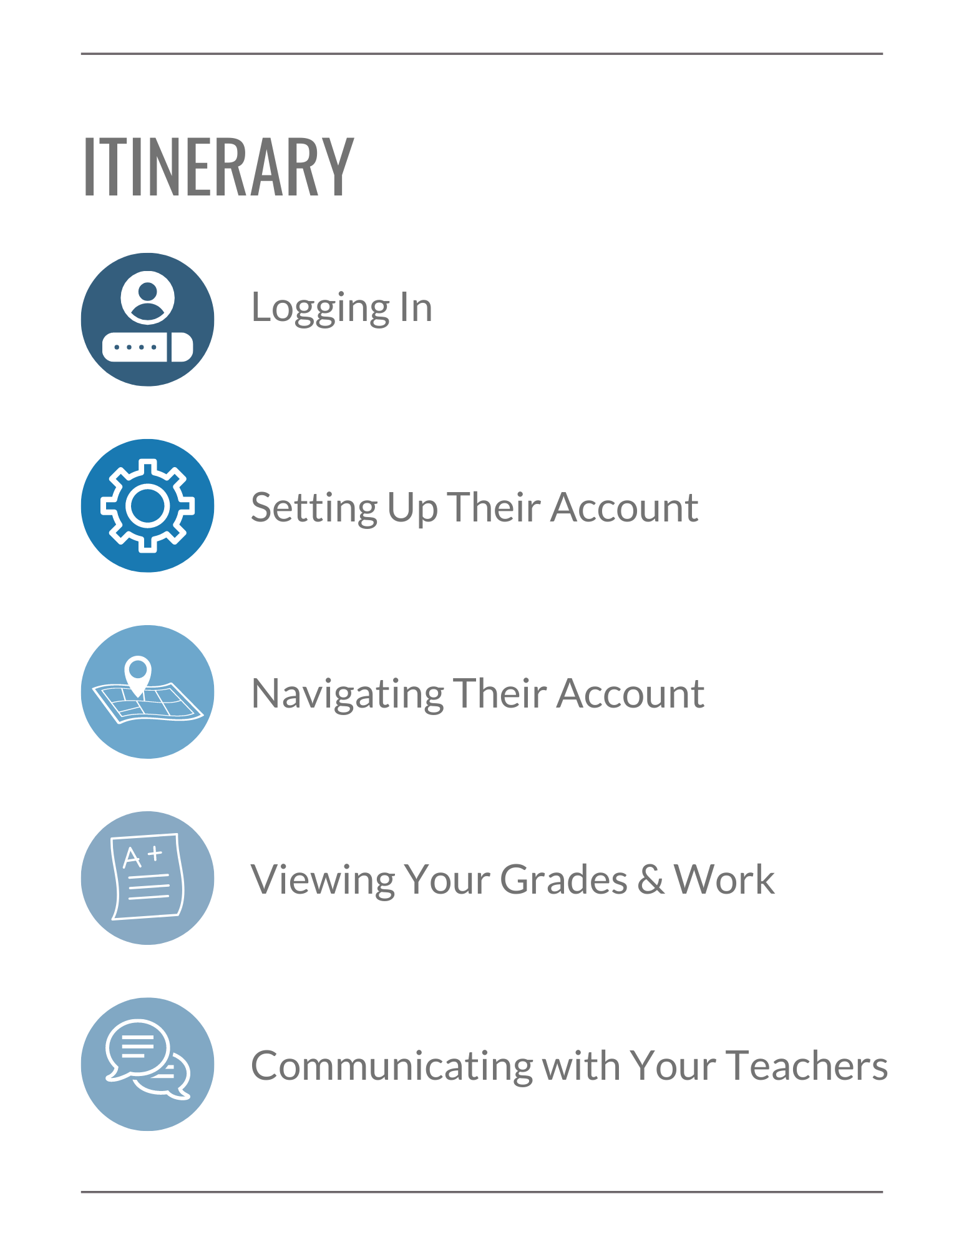

Checklist for your Parents

In this session, we’ll be covering the core Edsby skills for you to help your parents with. Your parents can use this checklist to ensure they can use Edsby’s many features. Click the hyperlinks to jump to the part of the document where each skill is discussed.

Logging In
I can login to my Edsby account.

Setting up my Account
I can setup my Notifications.
I can set my language preferences.

Navigating my Account
I can read articles in the News River.
I can view school information on the School Page.
I can view all my children on my Home Screen.
I can view my child’s Classes and upcoming assessments in their Calendar.
I can submit Planned Absences for my children.

Viewing my Child’s Grades and Work
I can view my child’s assessments and grades in their My Work Report.
I can view my child’s shared Learning Evidence in their Learning Story.
I can view my child’s Portfolio.

Communicating with my Child’s Teachers
I can send messages to my child’s teachers.
I can view teacher posts in my child’s Recent Activity feed.

Logging In
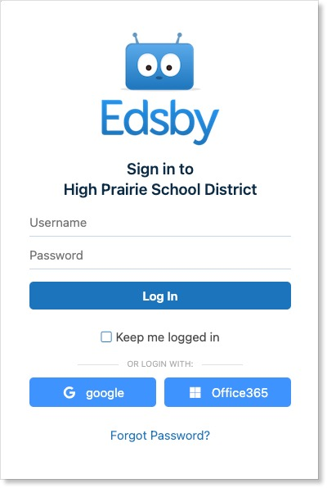
Just like when you login to Edsby, your parents need to type in the correct Edsby server address for your school or district. Every Edsby system has a unique URL, like http://xxxx/edsby.com, where xxxx is unique to the school or district.

Ask your school for your system’s Edsby server address and direct your parent there. Encourage them to bookmark it for easy access.

In addition to accessing Edsby through a desktop or mobile browser, your parents can keep up-to-date with your schooling on their mobile device by using the Edsby Mobile App.

Show them how to download the app by directing them to either Google Play or the App Store. The server address for the app is the same as required on the browser.

If your parents have additional questions about logging into Edsby, direct them to your school office.

Setting Up Their Account

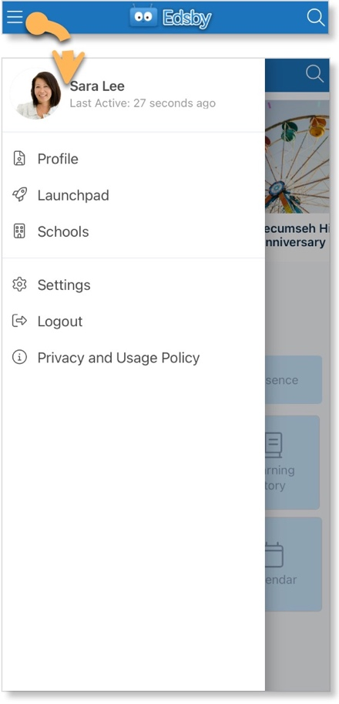
Notifications

With so many things happening inside Edsby, it is important to stay organized and up-to-date. Edsby makes this easy by enabling various notifications to ensure your parents are notified of the important things happening within your school, Classes, and Calendars, as well as their own Groups.

Your parents can access their Notification Settings by clicking the menu icon in the top left of their mobile Home Screen and selecting Settings.

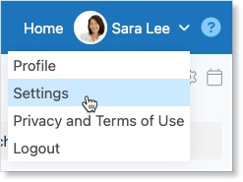

Or, if they are using a browser, they can access them by clicking the drop-down arrow next to their name and selecting Settings from the menu.

They will then select Notifications.

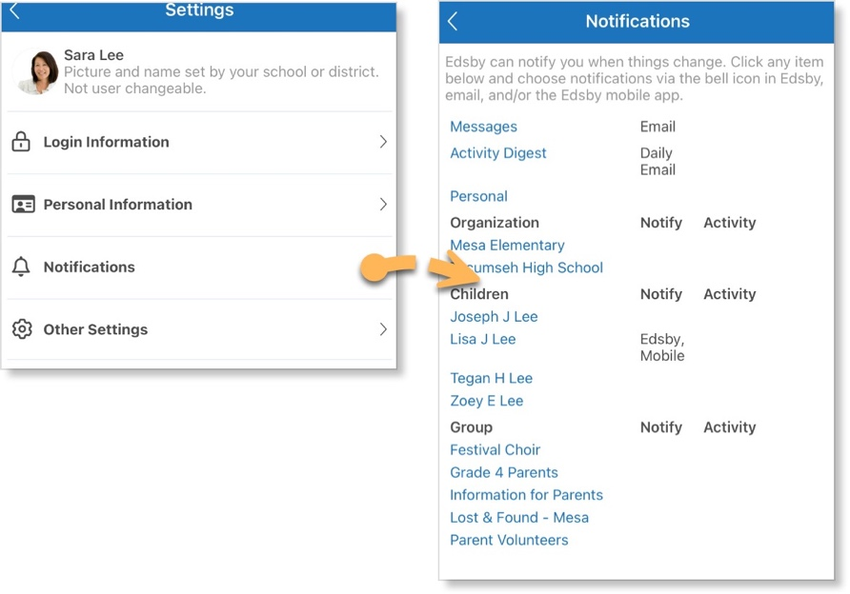
This provides your parent with a form to select and update notifications regarding their own Personal Calendar, your school, you and any siblings you have, and your parent’s own Groups.

They can choose to receive notifications through Email, Edsby itself, or straight to their mobile device.

Note: The first time your parents login from a browser, they will be prompted to turn on their notifications automatically. Encourage them to do this! They won’t have to worry about manually turning their notifications on.

A helpful resource on Notifications for Parents can be found here.

Language Preferences

Edsby is available in over 35 languages. By default, Edsby inherits the language of the web browser it is being accessed on. Additionally, Edsby supports Microsoft Translator and Google Translate browser extensions to enable your parents to translate any content within Edsby.

This enables your parents, if they don’t speak English, to use Edsby to gain insights into your progress at school in the language they prefer.

Language settings can be changed both in the browser as well as the Edsby Mobile App. Show your parents how to navigate to their Account Settings and select Other Settings.

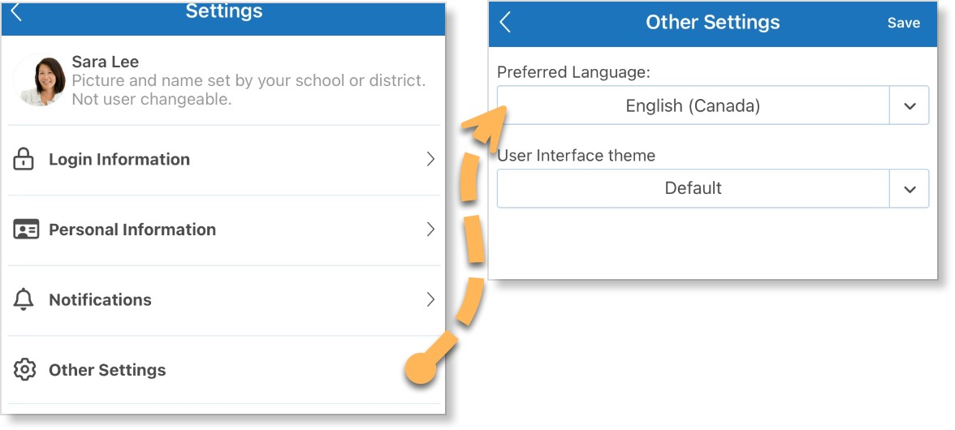

Your parents can change their preferred language in Edsby by clicking the drop-down arrow and selecting one of the languages listed. Ensure your parents click Save to update their settings.

Additional information on using Google Translate or Microsoft Translator with Edsby can be found here.

Navigating Their Account

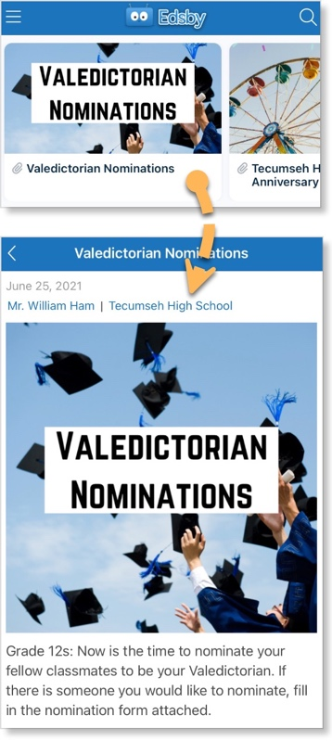
News River

The News River at the top of the Edsby Home Screen provides your parents with the news regarding the school district and each school they have children at. This is a great way for your parents to stay informed about everything happening at your school!

Scroll to navigate through the articles.

Clicking an article from the News River opens the full article.

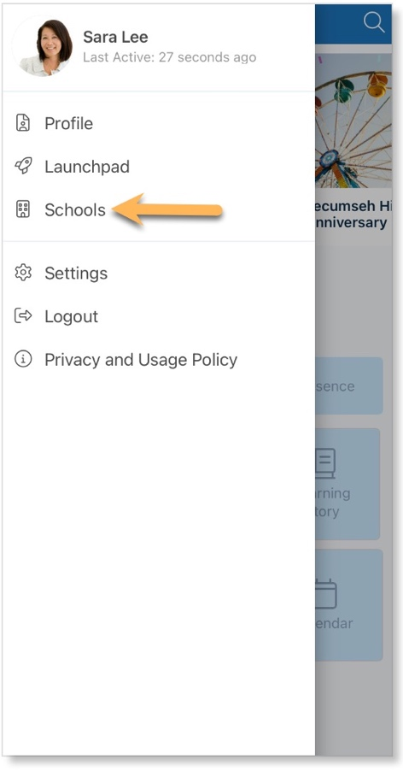
School Information

Your parents can access the school and district pages by clicking the menu in the top left of their mobile Home Screen and selecting the name of the school or district.

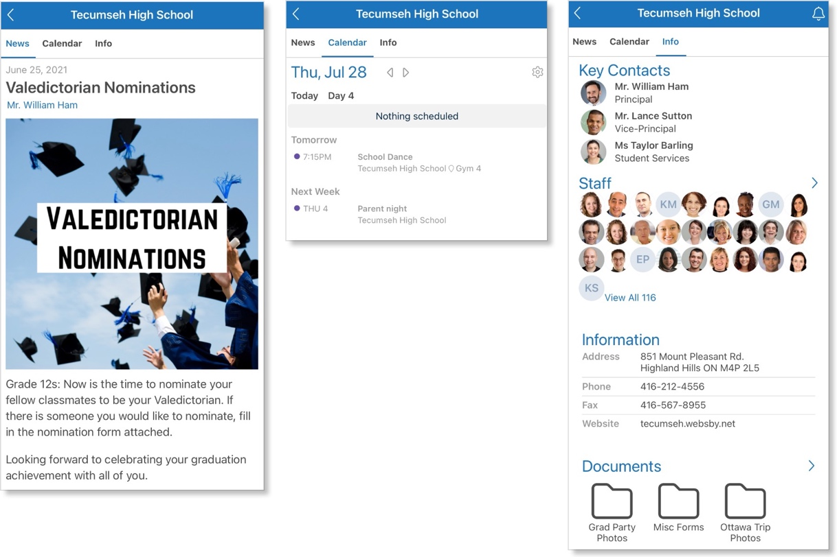
Your parents can scroll to view all school news posts.

Clicking Calendar opens the school Calendar for your parents to view.

Clicking Information opens important school information for your parents to view including:

- Key Contacts in the school

- Staff Panel, making it easier to contact any teacher or principal at the school through Edsby

- Contact Information for the school

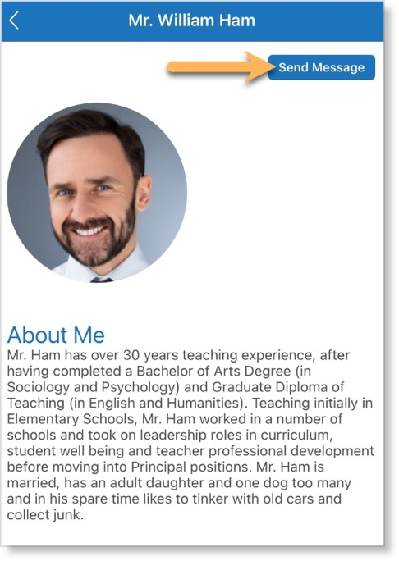
- A school-wide Documents Library

Your parents can quickly message any of the Key Contacts in Edsby by clicking their name, opening their mini-profile, and clicking Send Message.

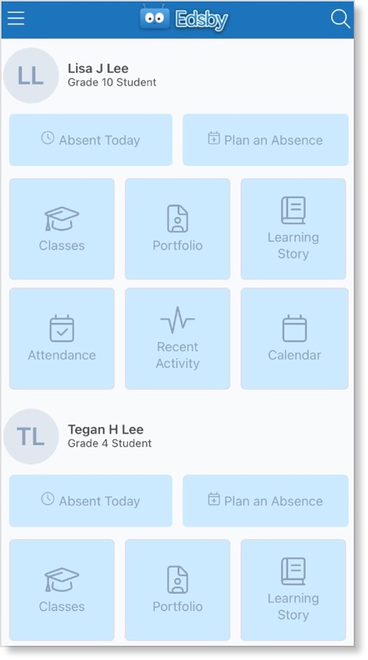
Managing Multiple Children

If your parent has multiple children, they will all be merged onto the parent’s single Edsby account.

On their Home Screen, they are provided with a list of their children. Show them how to scroll through each of their children and view the various options they have for each.

For each child, your parent can Plan an Absence, view their Portfolio and Learning Story, view their Classes, Recent Activity, and Calendar events. These quick links are the best ways to stay up-to-date on each of their children.

Student Calendars
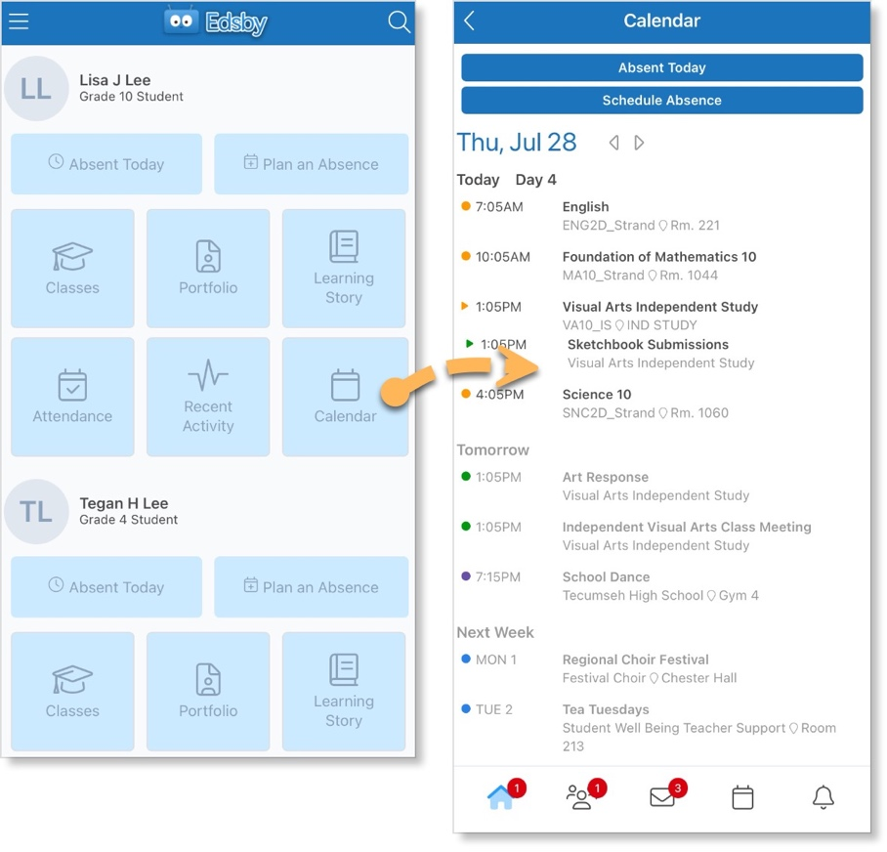

Clicking Calendar under your name on your parent’s account will display your Personal Calendar.

Here they can see each of the Classes you have in the day and if you have any upcoming assessments or events. Your parents can also schedule an absence for you from this screen.

Planned Absences

Edsby enables your parents to inform the school of any of your absences right from their mobile device.

For your parent to submit a planned absence for you, show them how to scroll to your name on the mobile app and choosing an option: Absent Today or Plan an Absence.

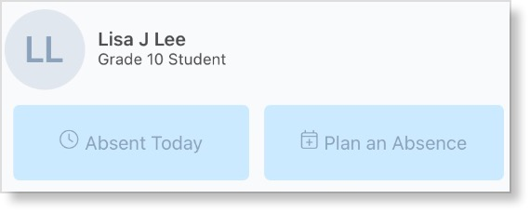
If you are going to be away for the whole day, your parent should click Absent Today and fill out the form.

If you are going to be away for a day in the future, a partial-day, or across multiple days, your parent should click Plan an Absence.

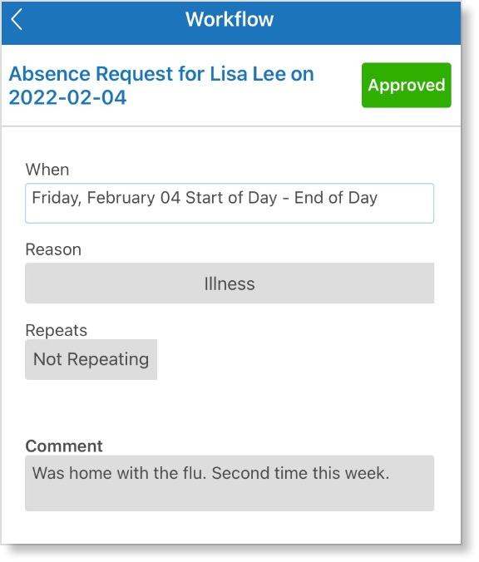

When your parent is finished, a submission receipt will be sent to their mailbox.

Once the school Office has reviewed and approved the absence, the submission receipt will change to Approved and be added to your Personal Calendar where your parent can view it.

More information on submitting Planned Absences can be found here.

Viewing your Grades and Work

My Work Report
If your parents want to see a detailed list of your upcoming assessments and any grades your teacher has shared, they can do so in your My Work Report, available both on mobile and browser.

On mobile, your My Work Report is available to your parents by clicking Classes under your name on their Home Screen and then clicking the My Work or New Results button under a Class. Here your parents can see a list of Class Assessments and any Grades your teacher has shared.

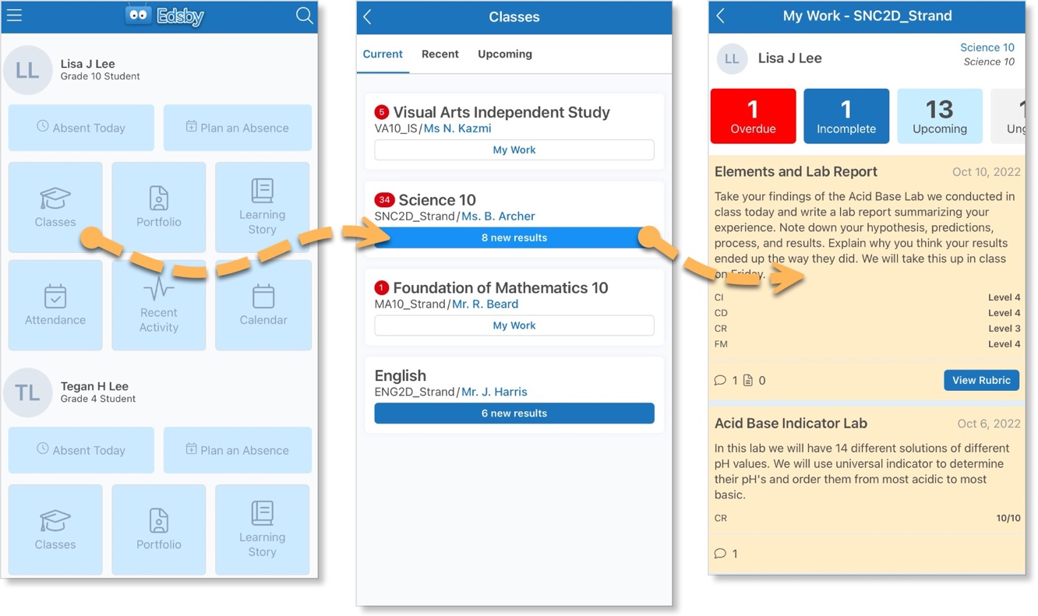

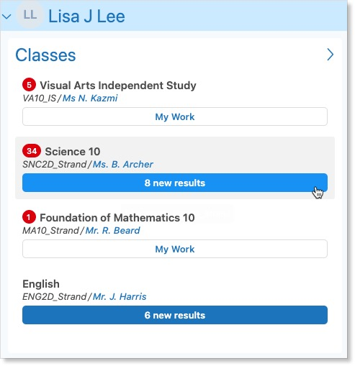

Your My Work Report is available to your parents on a browser by hovering over the Class name in your Classes Panel and clicking the My Work button.

More information on your My Work Report for parents can be found here.

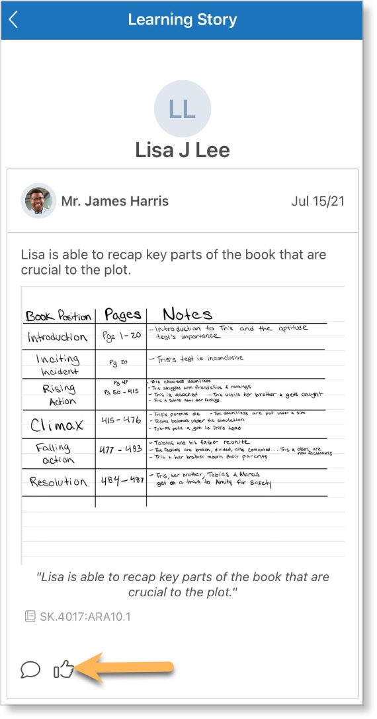
Learning Story

Edsby provides teachers with tools to capture Evidence regarding student learning. Once captured, teachers can share the Evidence with you and your parents in your Learning Story.

Your parents can view your Learning Story on mobile by clicking Learning Story under your name on their Home Screen.

Or on their browser Home Screen, they will find it under your Classes Panel.

Show your parents how they can like and comment on any posts in the feed and communicate with your teachers about each item of Evidence.

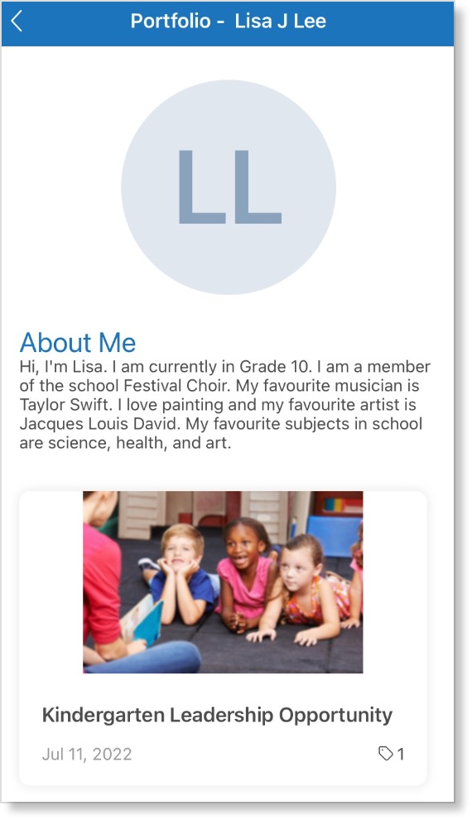
Portfolio

In your Portfolio, you can create posts about yourself and your academic or extracurricular success.

Your parents can view your Portfolio as a feed by clicking Portfolio under your name on their mobile Home Screen.

Communicating with your Teachers

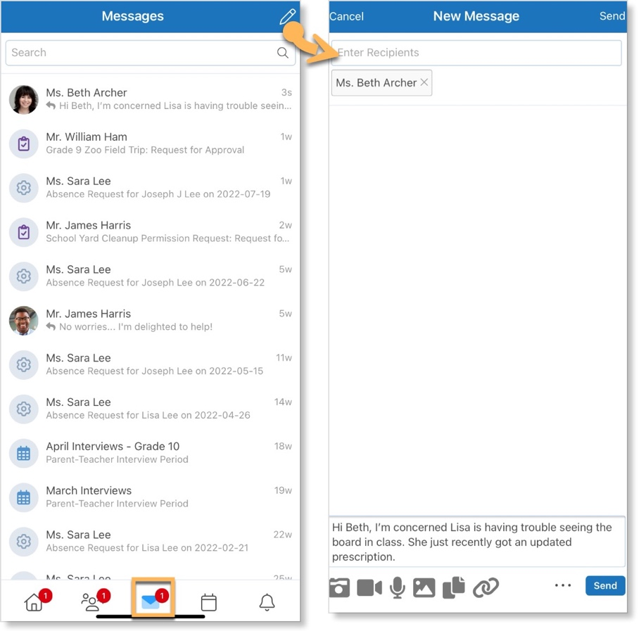
Messages

There may be times when your parents want to message one of your teachers. Edsby makes this easy with Edsby Messages.

Your parents have a mailbox available by clicking the envelope icon in their mobile Navigation Bar.

Here they can view previous conversations as well as compose a new message by clicking the icon in the top right.

Show them how to type in your teacher’s name in the recipient box and how to attach any files, if desired.

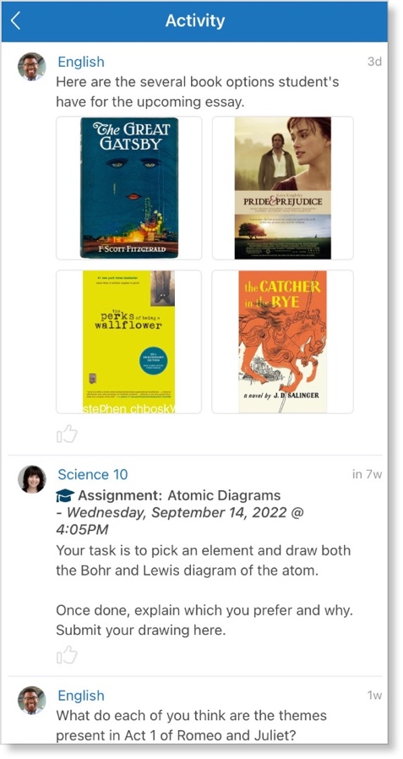

Recent Activity
If teachers have not enabled parents to enter a Class, all notes, events, and assessments posted by your teachers will be visible in your parents’ Recent Activity under your name on their mobile Home Screen.

Show your parents how they can let your teachers know they are reading the notes and assessments your teachers are posting by liking the posts in the feed.

We’ve covered it all! Have your parents review the checklist to make sure they feel comfortable completing all of the core Edsby skills for parents.

Logging In
I can login to my Edsby account.

Setting up my Account
I can setup my Notifications.
I can set my language preferences.

Navigating my Account
I can read articles in the News River.
I can view school information on the School Page.
I can view all my children on my Home Screen.
I can view my child’s Classes and upcoming assessments in their Calendar.
I can submit Planned Absences for my children.

Viewing my Child’s Grades and Work
I can view my child’s assessments and grades in their My Work Report.
I can view my child’s shared Learning Evidence in their Learning Story.
I can view my child’s Portfolio.

Communicating with my Child’s Teachers
I can send messages to my child’s teachers.
I can view teacher posts in my child’s Recent Activity feed.

Help and Support Resources
There are many places where you can find support for any questions you may have about Edsby or to just learn more about the platform.

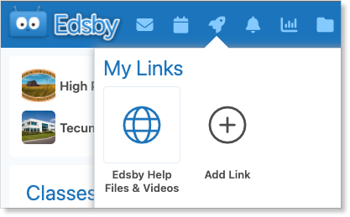
Launchpad
The Launchpad provides quick access to the support section of the Edsby website. Click Edsby Help Files & Videos for help using the Edsby platform.
Try adding your own links for quick access.

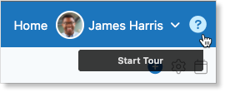
Edsby Tours
Click the question mark in the top right of any screen in Edsby to walk through a tour of the screen you are looking at. An optional overview video is provided as well.

Edsby Feedback Groups
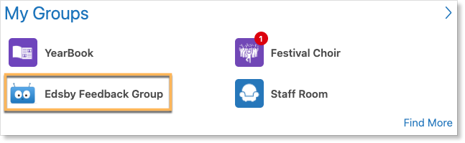
Every school or district is automatically enrolled in an Edsby Feedback Group. Both expert Edsby users and Edsby Customer Support Representatives monitor these groups to answer questions you may have. You may even be able to learn from other teachers in your school or district on how they like to use Edsby!

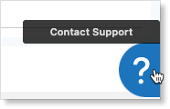
Edsby Customer Support
If you are unable to find the answer to your question through Edsby’s Help Files & Videos, you can click the question mark in the bottom right of any screen in Edsby to file a ticket with an Edsby Customer Support Representative.

